Hello year 2!
Below are activities that you could complete over the course of a week. Please keep in mind that the tasks below are only suggestions - you can complete as many as you would like at any time. Please connect to ClassDojo where you can stay in touch with your class teacher and also refer to the activities your teacher has posted for you.

Subject | Monday | Tuesday | Wednesday | Thursday | Friday
Reading & Writing  Poems on a Theme | What are rhyming words?  https://www.bbc.co.uk/bitesize/topics/zjhhvcw/articles/zqjgrdm  Watch the above video.  Can you make a list of rhyming words?  Make a list of adjectives to describe your family members. Can you think of other words that rhyme with the adjective you have listed?  This week you will be writing a poem about your family. | Today we look at how apostrophes are used to denote missing letters within words. Display Apostrophes for omission (see resources). Next, read Going Through the Old Photos (see resources). Highlight words where an apostrophe has replaced missing letters. For each example, ask chn to decide which two words have been joined using the apostrophe, e.g. who’s = who/is. Name letters that have been replaced by an apostrophe. | Read My Mum’s Put Me on the Transfer List by David Harner (see resources). Make sure chn all understand what a transfer list is. Discuss the poem. Did they find it funny? Why is the mum fed up with her son? Are any chn similar to the boy in the poem? You will be writing a poem in a similar style to this one and that is why they had to research why they might be put on the transfer list! | How to write a poem  https://www.bbc.co.uk/bitesize/topics/zjhhvcw/articles/zg6dng8  Watch the above video about how to write a poem.  What are the steps when writing a poem?  Think about the poem you have read this week. What is the structure?  Begin to think about reasons over the past 8 weeks that your Mum/Dad might have put you on the transfer list ;) | Look at the reasons you might be put on the transfer list from yesterday.  Have a go using the style and format of the original poem to write your own version.  Share on Dojo!  If you would like, ask Mum or Dad to record you reading your poem, we would love to see!
Topic-History, Geography, Science & RE  If you are looking for additional writing activities that link to topic lessons, Jane Considine from the Training Space (On YouTube) holds daily writing lessons that you can watch live or on catch up on their YouTube channel. | Science  It is new summer and with the change in weather we are seeing a lot more bugs out! Especially butterflies.  Watch the video below about the lifecycle of a butterfly.  https://www.youtube.com/watch?v=O1S8WzwLPlM  Create a visual representation of the lifecycle of a butterfly. Have a go using some of the key words you heard in the video | History  Last week you looked at life in Britain during the war.  How have things changed?  This week have a look at the attached PowerPoint about propaganda posters. These were used to recruit men to serve in the military.  Your task is to create your own propaganda poster. | Geography  Last week you looked at different types of settlements.  This week have a go at creating your own settlement.  You can choose:  -a village  -a city  -a town  remember what each of those needs to be considered one of the above.  What would you name your settlement? Be creative! | RE  Last week you started to look at what it means to care for our world.  While out walking I have noticed lots of rubbish on the roads, especially gloves and masks  Create a poster for your community to remind them how to care for the environment and local community.  When you go for a walk, post your poster so that everyone can see! | News  Watch Espresso News Bites.  What has happened this week?  Write a short paragraph about how this weeks news had made you feel.
Maths  The white rose maths hub has plenty of resources that you can access at home for free.  You can access their problem on the day using the link below.  https://whiterosemaths.com/resources/classroom-resources/problems/ | Problem solving week!  Today’s problems are all dealing with addition | Problem solving week!  Today’s problems are all dealing with subtraction | Problem solving week!  Today’s problems are all dealing with multiplication | Problem solving week!  Today’s problems are all dealing with division | Problem solving week!  Today’s problems are a mixture of all 4 operations.
Creative Time | 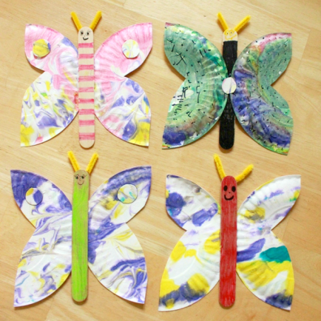  As you have learned about butterflies in science, have a go at making a butterfly using an ice lolly stick and some paper plates | https://www.growingajeweledrose.com/2015/02/rock-candy-experiment.html  have a look at the above link and see if you can make your own rock candy at home! | 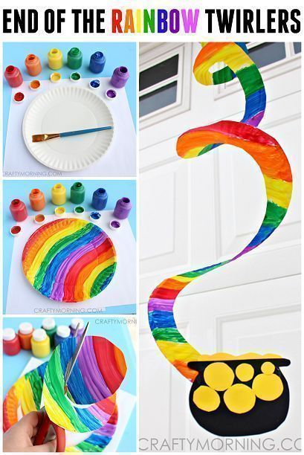  As tomorrow is Thursday and we clap for the NHS, have a go at making a new window decoration using a paper plate. Please note – you don’t have to use paint, markers will be fine and less messy! | https://crafting-news.com/rainbow-bubbles-snakes/  I love the look of this! With the beautiful weather we are having please try this and let us know how it went! | 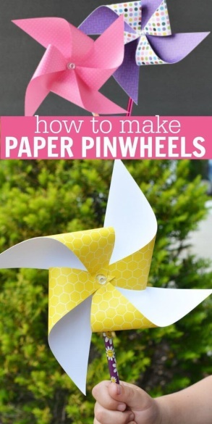  Happy Friday!  https://www.onecrazymom.com/diy-paper-pinwheels/  It’s half term! Even though it might not feel like it!  Have a go at making some pinwheels for your garden

Below are suggested activities that you could be practicing on a regular basis.

Spellings – Keep referring to the year 2 common exception words that you must know how to read and write in year 2.  Keep an eye out for weekly spelling patterns on class dojo. Make sure you have signed up via the email link your teacher has sent you.  You could do any of the following activities:  -Create a word search with your spellings.  -Write silly sentences with your spellings.  -Rainbow spellings  -Write a story that includes each of your spelling words.  -Hold a quiz with the members of your family. | Timestables - knowing our timestables is extremely important, especially your x2, x3, x5, x10’s.  Don’t forget that we also need to know the inverse. E.g. 12 divided by 2 is 6.  Reading- Read a book, magazine, article, leaflet, poster, newspapers. See if you can share what you’ve read with someone else in your family.  Phonics- play on phonics play as it’s a great way to practice your alien words and real words. | Physical Activity - make sure you are trying to be active every day.  - Watch Joe Wicks PE lessons live every day at 9:00am or watch his previous videos at any time of day.  - Create your own circuit and teach it to the members of your family.  - Watch some of the Just Dance videos on YouTube and get dancing for 20 - 30 minutes.  - Have a go at doing some Cosmic Yoga on YouTube

