Week 1 Day 3
Spellings

Practise these words.

Read | Trace | Practise | Practise | Practise | Practise
available | available
average | average
awkward | awkward
bargain | bargain
bruise | bruise

Now write a sentence for each word. Can you spell it correctly in each sentence without looking at the table? Can you write a sentence using all of the words?
__________________________________________________________________________________________________________________________________________________________________________________________________________________________________________________________________________________________________________________________________________________________________________________________________________________________________________________________________________________________________________________________________________________________________________________________________________________
__________________________________________________________________
Maths
Use bar models to compare and order these fractions.
- $\frac{3}{4}$ , $\frac{1}{2}$ , $\frac{1}{4}$ , $\frac{3}{8}$
smallest |  |  |  |  | biggest

- $\frac{2}{5}$ , $\frac{1}{2}$ , $\frac{2}{2}$ , $\frac{3}{5}$
smallest |  |  |  |  | biggest

- $\frac{3}{4}$ , $\frac{1}{3}$ , $\frac{1}{2}$ , $\frac{4}{6}$
smallest |  |  |  |  | biggest

- $\frac{2}{3}$ , $\frac{1}{4}$ , $\frac{5}{6}$ , $\frac{7}{8}$
smallest |  |  |  |  | biggest

- $\frac{3}{4}$ , $\frac{2}{5}$ , $\frac{1}{2}$ , $\frac{1}{4}$
smallest |  |  |  |  | biggest

- $\frac{2}{3}$ , $\frac{1}{2}$ , $\frac{5}{6}$ , $\frac{1}{3}$

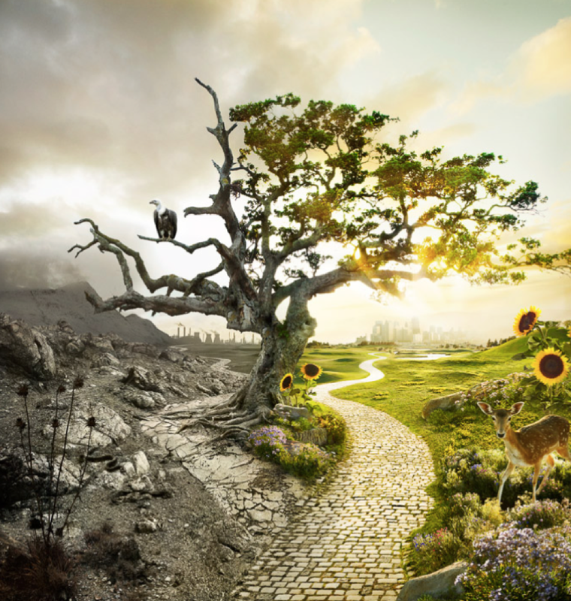
English
Answer the questions
How are the two sides of the picture different?
Why do you think they are different?
What do you think it would feel like to be in either place?
How might the two cities be different?
What will the people in both cities be like?
Are there any similarities between the two sides?
What might the different animals be thinking?
__________________________________________________________________________________________________________________________________________________________________________________________________________________________________________________________________________________________________________________________________________________________________________________________________________________________________________________________________________________________________________________________
____________________________________________________________________________________________

