Dear Parents and Carers,

As we move towards the middle of the summer holiday I thought I would provide you with an update regarding our September return. We are committed to getting our pupils back into school as quickly and efficiently as possible but I appreciate that some of you will be a little apprehensive regarding what the autumn term may look like and I trust that this letter will dispel any concerns you may have.

Working in conjunction with our staff, their union representatives, the Board of Trustees and the Local Authority we have devised a fully risk assessed solution that meets current government directives, enabling every child to return, in a social distanced learning environment, whilst not compromising the educational experience (and ultimately the progress) of your child. On our return we will continue to operate control measures in line with Public Health England to minimise, manage or contain any potential outbreak or confirmed case of COVID-19 in the academy community. This will include: self-isolation for 14 days, the use of the NHS testing and ‘track and trace’, improved signage and distance control on corridors and within classrooms as well as a high focus on good hygiene by having hand sanitiser available in every classroom. We encourage you to play your part by ensuring that your child comes to school with their own equipment which should include a pen, pencil, rubber, rule, sharpener and a calculator. It is important that this is kept for their own personal use and not shared with other pupils.

During the first week of term there will be a phased return of year groups, this will enable us to fully train the pupils regarding expectations and behaviours on their first day and gradually build up the numbers in the academy. It is expected that from Monday 14th September all pupils will be fully back in school. The return date and timings of the day are shown in the tables below.

Secondary Phase
 | Return Date | Start time | Break time | Lunch time | Dismissal
Year 7 | Monday 7th September onwards. | 8.30am | 10.45 – 11.00am | 12.00 – 12.30pm | 2.30pm
Year 8 | Thursday 10th September | 8.45am | 11.15– 11.30am | 12.45 – 1.15pm | 2.45pm
Year 9 | Friday 11th September onwards. | 9.30am | 11.45 – 12.00pm | 1.00 – 1.30pm | 3.30pm
Year 10 | Wednesday 9th September | 8.45am | 11.15– 11.30am | 12.30 – 1.00pm | 2.45pm
Year 11 | Tuesday 8th September | 8.30am | 10.45 – 11.00am | 12.15 – 12.45pm | 2.30pm
Year 12 | Monday 7th September onwards. | 9.30am | 11.45 – 12.00pm | 1.00 – 1.30pm | 3.30pm
Year 13 | Tuesday 8th September | 9.30am | 11.45 – 12.00pm | 1.00 – 1.30pm | 3.30pm

To maintain social distancing students will remain in year groups, within specific areas of the academy, with the teaching staff travelling around the building to deliver lessons. Year groups have been paired to allow for staggered start, break, lunch and finish times and the pairings are in different zones so that they will not intermingle at these times. To ease congestion and maintain a smooth flow of children during lunch the restaurant will be serving a reduced menu. These revised timetables have been designed to maintain the current percentage of teaching time for each subject which means that the quality of education being provided has not been compromised. It also enables us to return, with relative ease, to our ‘normal’ timetable at any point in the academic year should the government remove the current directives regarding social distancing.

As we move into the next stage of recovery from this pandemic it will be important that we are always kind, compassionate and helpful to one another and continue to appreciate that our school community, like the whole nation, will have varying degrees of confidence regarding our full return post COVID. At the forefront of our minds, central to every decision that we take will be the children in our care, getting them back to school settled, safe and enjoying the challenge of learning.

It is possible that the guidelines provided by the government will change before our return in September. With this in mind staff will be working throughout August and will adapt these plans, should this be required, to ensure that our return is as smooth as possible. Whatever the circumstances I will write to you all again in late August to provide an update regarding our September return.

I wish you and your families good health and look forward to working collaboratively to ensure our school community can return in September.

Yours sincerely,

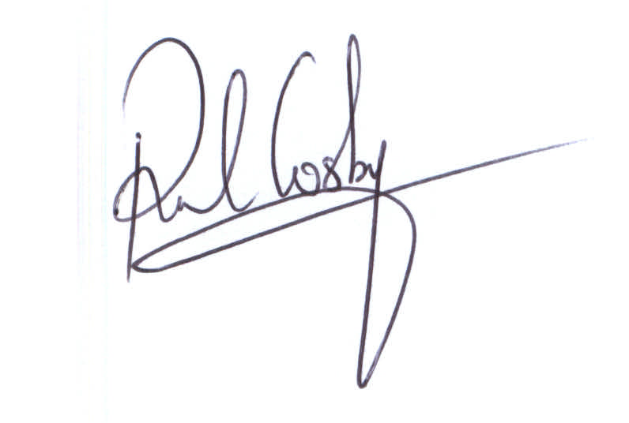
Mr P Cosby
Interim CEO & Principal

