Can add amounts of money within £1 and extend beyond £1
Test1 Can add amounts of money within £1 and extend beyond £1
- Which child has the most money? Explain your answer.

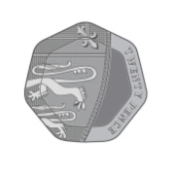
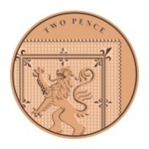
Mohammed Oscar Livy
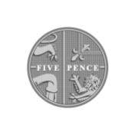
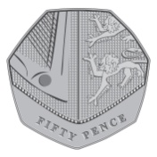

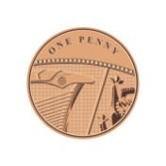
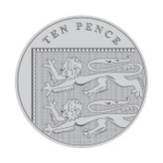

- Fatiha buys an apple and a banana. How much money does she spend altogether?
89p
£1
36p

- Here are the costs of buying a drink and a sandwich at the school fair this year compared to last year.
 | Drink | Sandwich
This year | 37p | £1 and 4p
Last year | 43p | 93p

Was buying one drink and one sandwich more expensive this year or last year? Explain your answer.

