Hello year 2!
Below are activities that you could complete over the course of a week. Please keep in mind that the tasks below are only suggestions - you can complete as many as you would like at any time. Please connect to ClassDojo where you can stay in touch with your class teacher and also refer to the activities your teacher has posted for you.

Subject | Monday | Tuesday | Wednesday | Thursday | Friday
Reading & Writing | What is a persuasive text?  Discuss what the word persuasive means. Remind the children it’s when you want someone to buy something or simply say yes.  Look at the powerpoint.  See if you can find any adverts or posters that are persuasive. | Go through the powerpoint all about saving Java Rhinos.  Can you make a persuasive poster to tell people why it is important to save the Rhinos? | Pick your favourite toy. Think about what it looks like, what it can do, why people must own it, how much fun you can have with it etc.  Write a letter to a friend telling them why they need to go out and buy this fantastic toy. | Read the persuasive text about wearing school uniforms.  Write down 5 key reasons that tell you why it is important to wear school uniform? | Read a story of your choice and write a summary of what happened. Can you draw a picture of your favourite part.
Topic-History, Geography, Science & RE  If you are looking for additional writing activities that link to topic lessons, Jane Considine from the Training Space (On YouTube) holds daily writing lessons that you can watch live or on catch up on their YouTube channel. | Science  Can you make your own parachute using a plastic bag. Follow the instructions and see how safely your parachute can land.  Try throwing it from different heights and timing how long it takes to reach the ground. | History  https://www.bbc.co.uk/bitesize/clips/zw76pv4  Watch the clip about the different toys the children used to play with during World War 1.  Can you make a model of a toy from WW1 from different materials? Try junk modeling. | Geography  https://www.bbc.co.uk/bitesize/topics/zyhp34j/articles/zhw7vk7  Watch this clip all about Europe.  Make a fact file about the different landmarks you can see, the food you can eat, the flags etc. | RE  https://www.bbc.co.uk/bitesize/clips/z934wmn  Watch the clip of the good Samaritan.  Think of a time where you have helped someone. | News  Watch Newsround  What has happened this week?  Write a short paragraph about how this weeks news had made you feel.
Maths  The white rose maths hub has plenty of resources that you can access at home for free.  You can access their problem on the day using the link below.  https://whiterosemaths.com/resources/classroom-resources/problems/ | Fractions  Can you remember how to find ½, 1/3, ¼ of an amount.  Task: Complete the fractions booklet.  You may even want to find fractions of objects around your house. | Multiplication and Division  Can you count in 2’s, 5’s, 10’s, 3’s?  Can you draw a matching array to help you answer the questions?  Task: Complete the booklet over the next few days. | Multiplication and Division  Task: Continue completing the booklet. | 3D shapes  Can you remember the names of the 3D shapes?  Can you spot 3D shapes around your house?  Do you remember the properties of the 3D shapes?  Task: Sort the objects and match the shapes. | Measuring  Do you remember how to measure accurately using a ruler?  Have a go at measuring objects around your house.  Task: Measure the chocolate bars using a ruler.
Creative Time | https://skintchef.co.uk/easy-homemade-kids-shortbread-recipe/  I love baking! Why not have a go at this simple recipe.  Let’s see if you can make shortbread. | Bubble painting  See if you can make your own picture using paint, washing up liquid and a straw.  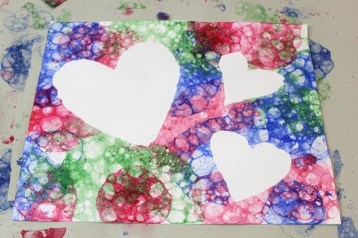 | String painting  Can you make a picture with paint and string?  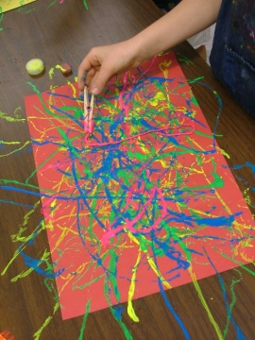 | https://www.bbc.co.uk/bitesize/clips/z8jrhv4  Have a go at making this creation. | https://www.bbc.co.uk/bitesize/clips/zg9b6fr  Have a go at making a print using a repeated pattern. It is just like making your own newspaper or wrapping paper.

Below are suggested activities that you could be practicing on a regular basis.

Spellings – Keep referring to the year 2 common exception words that you must know how to read and write in year 2.  Keep an eye out for weekly spelling patterns on class dojo. Make sure you have signed up via the email link your teacher has sent you.  You could do any of the following activities:  -Create a word search with your spellings.  -Write silly sentences with your spellings.  -Rainbow spellings  -Write a story that includes each of your spelling words.  -Hold a quiz with the members of your family. | Timestables - knowing our timestables is extremely important, especially your x2, x3, x5, x10’s.  Don’t forget that we also need to know the inverse. E.g. 12 divided by 2 is 6.  Reading- Read a book, magazine, article, leaflet, poster, newspapers. See if you can share what you’ve read with someone else in your family.  Phonics- play on phonics play as it’s a great way to practice your alien words and real words. | Physical Activity - make sure you are trying to be active every day.  - Watch Joe Wicks PE lessons live every day at 9:00am or watch his previous videos at any time of day.  - Create your own circuit and teach it to the members of your family.  - Watch some of the Just Dance videos on YouTube and get dancing for 20 - 30 minutes.  - Have a go at doing some Cosmic Yoga on YouTube

