Week 1 Day 4
Spellings

Practise these words.

Read | Trace | Practise | Practise | Practise | Practise
category | category
cemetery | cemetery
committee | committee
communicate | communicate
community | community

Now write a sentence for each word. Can you spell it correctly in each sentence without looking at the table?

__________________________________________________________________________________________________________________________________________________________________________________________________________________________________________________________________________________________________________________________________________________________________________________________________________________________________________________________________________________________________________________________________________________________________________________________________________________
__________________________________________________________________
Maths
Rounding
Remember to look at the lower digit to the number you are rounding.  E.g: round 46 to the nearest 10.  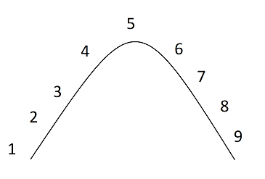  Use the hill. Lower digit will tell you which you will have to round.  46 rounds to 50 | A. Round the following numbers to the nearest 10.  1. 13  2. 23  3. 18  4. 98  5. 134  6. 192  7. 372  8. 1243
B. Round the following numbers to the nearest 100.  1. 140  2. 260  3. 180  4. 345  5. 352  6. 985  7. 1050  8. 6929 | C. Round the following numbers to the nearest 1000.  1. 2300  2. 1978  3. 4368  4. 6500  5. 9500  6. 13483  7. 49268  8. 123436
D. Round the following numbers to the nearest tenths.  1. 4.93  2. 5.03  3. 2.68  4. 7.55  5. 3.44  6. 12.09  7. 18.89  8. 44.347 | E. Round the following numbers to the nearest hundredths.  1. 0.273  2. 1.595  3. 6.473  4. 2.571  5. 8.995  6. 5.721  7. 0.425  8. 44.5564
English
Use all of the sentences you have written over the last few days to help you. Imagine you are looking around, half the world is in colour and half is in black and white. Carry on this paragraph (be imaginative).

It had been a time of great change. Many suggest the humans were to blame. Their world was disappearing inch by precious inch: a lush, sun-drenched land full of colour and life becoming a barren, ruinous, grey wasteland. As the dust settled…

_____________________________________________________________________________________________________________________________________________________________________________________________________________________________________________________________________________________________________________________________________________________________________________________________________________________________________________________________________________________________
__________________________________________________________________________________________________________________________________________________________________________________________________________________________________________________________________________________________________________________________________________________________________________________________________________________________________________________________________________________________________________________________
_____________________________________________________________________________________________________________________________________________________________________________________________________________________________________________________________________________________________________________________________________________________________________________________________________________________________________________________________________________________________

