Geography Focus
WORLD ART
Challenge yourself to travel the world through artwork. Can you produce one piece of artwork from each of the seven continents of the world and plot them onto a world map?
Challenge for Continent 1:

• Jackson Pollock-inspired splatter art (America)

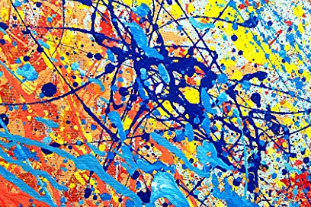

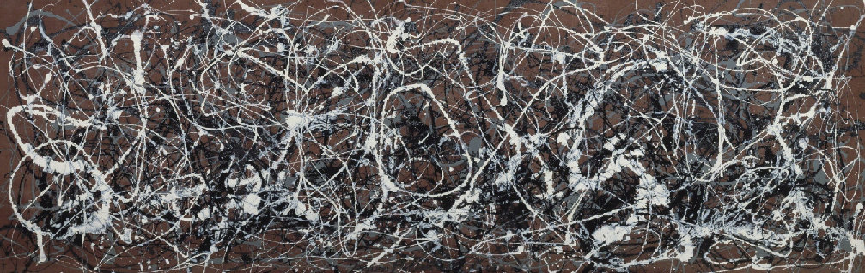

Find out some information about Jackson Pollack and produce a painting using the same style.

