Combined Physics

Cheeky 1 Markers

Paper 1
- Give the equation that links kinetic energy mass and speed | kinetic energy = 0.5 × mass × (speed)²
- Give the equation that links gravitiational potential energy, mass, gravitational field strength and height | gravitational potential energy = mass  × gravitational field strength × height
- Give the equation that links power, energy transferred and time
- Give the equation that links work done, time and power | 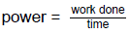
- Give the equation that links efficiency, useful output energy transfer and total input energy transfer | 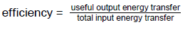
- Give the equation that links resistance, current and power | Power = (current)² x resistance
- Give the equation that links time, energy transferred and power | Energy transferred = power x time
- Give the equation that links charge flow, potential difference and energy transferred | Energy transferred = charge flow x potential difference
- Give the equation that links mass, volume and density | 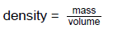
- Give the equation that links current, time and charge flow | Charge flow = current x time
- Give the equation that links potential difference, current and resistance | Potential difference = current x resistance
- Give the equation that links current, potential difference and current | Power = potential difference x current
- Define the term specific heat capacity | the amount of energy  required to raise the temperature of one kilogram of the substance  by one degree Celsius.
- Define the term power | Power is defined as the rate at which energy is transferred or the  rate at which work is done.
- Wasted energy is often dissipated ,give the ways this energy is generally transferred to the surroundings | Heat and sound
- Describe what is meant by the term “renewable energy resource” | A renewable energy resource is one that is being (or can be)  replenished as it is used.
- Give the main energy resources available for use on earth | Fossil fuels, nuclear fuel, bio-fuel, wind, hydroelectricity, geothermal, the tides, the sun and water waves
- Describe the environmental impacts of using fossil fuels | They are non-renewable so we will run out, when burned they produce CO₂ which causes global warming, they can cause huge environmental disasters if not removed from the stores safely (eg oil spills)
- Sketch the current potential difference graph for a fixed resistor | 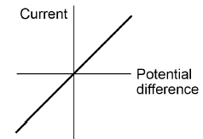
- Sketch the current potential difference graph for a filament lamp | 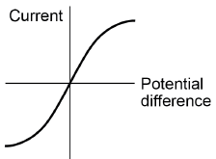
- Describe why the filament lamp has a different shaped current potential difference graph to the fixed resistor | As temperature increases the resistance increases, when this increases the current will decrease, so the graph will curve slightly
- Sketch the current potential difference graph for a diode | 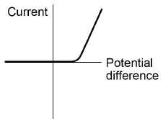
- Describe why the diode has a different shaped current potential difference graph to the fixed resistor | The current can only flow through the diode in one direction, because the diode has very high resistance in the reverse direction
- Give the potential difference and Frequency of mains electricity in the UK | 230V 50Hz
- Draw the particle arrangement in solids, liquids and gases | 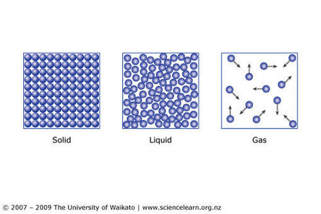
- Define the term internal energy | The total kinetic energy and potential energy of all the particles which make up a system
- Describe how heating changes the internal energy within a system | Heating increases the energy of the particles within the system, this either raises the temperature of the system or produced a change of state.
- Define the term specific heat capacity | The specific heat capacity of a substance is the amount of energy required to raise the temperature of one kilogram of the substance by one degree Celsius
- Define the term specific latent heat | The amount of energy required to change the state of one kilogram of the substance with no change in temperature.
- On this graph label the specific latent heat of fusion and the specific latent heat of vaporisation, and the 3 states of matter.  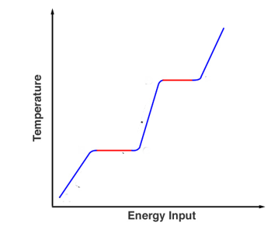 | 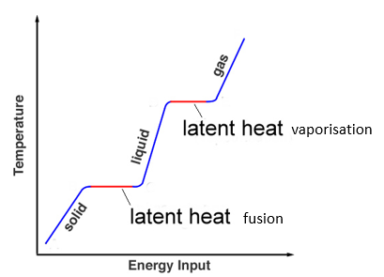
- Describe the motion of particles in a gas | Particles are in constant random motion.
- Describe and explain how increasing the temperature of a gas will affect the pressure exerted by the gas on a container | The pressure will increase because the particles will have a higher kinetic energy and will collide more frequently with the sides of the container.
- Describe how the size of a nucleus compares to the size of an atom. | A radius of the nucleus is 1/10 000 of the radius of an atom
- Give the number of protons, neutrons and electrons in an atom of Nickel | Protons = 28  Electrons = 28  Neutrons = 59-28 = 31
- Define the term isotope | An element with the same number of protons and electrons (same atomic number), but different numbers of neutrons (therefore a different mass number)
- Some isotopes are unstable, and therefore radioactive. Explain why these isotopes decay | They are unstable so give out radiation randomly to become stable
- Define the term half life. | This is the time it takes for the number of nuclei of the isotope in a sample to half, or the time it takes for the count rate from a sample containing the isotope to half.
- Define the term Radioactive contamination | The unwanted presence of materials containing radioactive atoms on other materials.
- Define the term Irradiation | The process of exposing an object to nuclear radiation – an irradiated object does not become radioactive.

Paper 2
- Give the equation that links mass, weight and gravitational field strength | weight = mass × gravitational field strength
- Give the equation that links force, distance and work done | work done = force × distance  (along the line of action of the force)
- Give the equation that links the spring constant, force applied to a spring and extension | force applied to a spring = spring constant × extension
- Give the equation that links time, speed and distance | distance travelled = speed × time
- Give the equation that links acceleration, time taken and change in velocity
- Give the equation that links resultant force, mass and acceleration
- Give the equation that links velocity, mass and momentum | Momentum = mass x velocity
- Give the equation that links wave speed, frequency and wavelength | Wave speed = frequency x wavelength
- Describe the difference between scalar and vector quantities. | Scalar quantities have magnitude only, whereas vector quantities have magnitude and an associated direction.
- Describe the difference between a contact force and a non-contact force. | With contact forces the objects are physically touching, however with non-contact forces the objects are physically separated.
- Give examples of contact forces | Friction, air resistance, tension
- Give examples of non-contact forces | Gravitational force, electrostatic force and magnetic force
- Are forces scalar or vector quantities, explain your answer | Vector, as they have magnitude and a direction which they act in.
- How many joules of work is done, when a force of one newton causes a displacement of one metre | 1 Joule  Because 1 Joule = 1 Newton – metre
- Explain the difference between speed and velocity | Speed is a scalar quantity, velocity is a vector quantity. This means that velocity also involved the direction the object is travelling in.
- Give the typical speeds of someone walking, running, cycling and the speed of sound in air | Walking ~ 1.5 m/s  Running~ 3m/s  Cycling ~ 6 m/s  The speed of sound in air is 330m/s
- Give Newton’s First law | If the resultant force acting on an object is zero and:  • the object is stationary, the object remains stationary  • the object is moving, the object continues to move at the same speed and in the same direction. So the object continues to move at the same velocity
- Give Newton’s Second law | The acceleration of an object is proportional to the resultant force acting on the object and inversely proportional to the mass of the object.  Force = mass x acceleration
- Give Newton’s Third law | Whenever two objects interact, the forces they exert on each other a equal and opposite.
- Give the equation for the stopping distance | Stopping distance = thinking distance + breaking distance
- Give factors that can affect the thinking distance | Alcohol or drugs, distraction, speed
- Give factors that can affect the breaking distance | Road conditions, weather, speed
- Define the term conservation of momentum | In a closed system, the total momentum before an event is equal to the total momentum after the event
- Describe the motion of a longitudinal wave | The oscillations are parallel to the motion of the wave
- Describe the motion of a transverse wave | The oscillations are perpendicular to the motion of the wave
- Give the order of the electromagnetic spectrum from highest frequency to lowest frequency. | Gamma, X-Rays, Ultraviolet, Visible light, Infrared radiation, microwaves, Radiowaves
- Give a use of radio waves | Communication (eg radio) because they produce oscillations in electrical circuits
- Name the types of Electromagnetic radiation which are hazardous to human tissue and give their effect | UV, X-Rays and gamma are ionising.
- Give a use of microwaves | Satellites and cooking food
- Give a use of Infrared radiation | Electric heaters
- Give a use of visible light | Fibre optic communications
- Give a use of ultraviolet waves | Sun tanning and energy efficient lamps
- Give a use of X-rays and Gamma rays | Medical imaging and treatments
- Describe whether magnetism is a contact or non-contact force | Non-contact, the objects don’t need to touch to experience attraction or repulsion
- Describe the difference between a permanent magnet and an induced magnet | A permanent magnet produces its own magnetic field. An induced magnet is a material that becomes a magnet when it is placed in a magnetic field, and always causes a force of attraction. When removed from the magnetic field it loses most/all of its magnetism quickly.
- Name the magnetic elements | Iron, cobalt, nickel (steel is NOT an element but is an alloy of iron so is magnetic)
- Name the part of a magnet where the field is strongest | At the poles
- Draw the field lines surrounding a bar magnet | 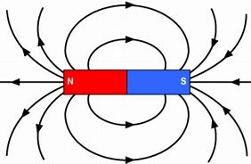
- Give 2 factors which affect the strength of the magnetic field around a wire | Current and the distance from the wire
- Describe how the strength of the field could be increased | Shape the wire into a solenoid, add an iron core to the solenoid
- Give the factors represented by Fleming’s left hand rule | Force (thumb)  Magnetic field (index finger)  Current (middle finger)
- Describe what is meant by the “motor effect” | When a conductor carrying a current is placed in a magnetic field the magnet producing the field and the conductor exert a force on each other.
- Describe how the direction of an electric motor can be changed | Change the direction of the magnetic field, change the direction of the current.

