Week 3 Day 3
Spellings

Practise these words.

Read | Trace | Practise | Practise | Practise | Practise
occupy | occupy
occur | occur
opportunity | opportunity
parliament | parliament
persuade | persuade

Now write a sentence for each word. Can you spell it correctly in each sentence without looking at the table?

__________________________________________________________________________________________________________________________________________________________________________________________________________________________________________________________________________________________________________________________________________________________________________________________________________________________________________________________________________________________________________________________________________________________________________________________________________________
__________________________________________________________________

Maths
Perimeter – is the length around the outside of a shape – remember to find the perimeter we need to add all of the sides together. Calculate the perimeter for these shapes.
 | 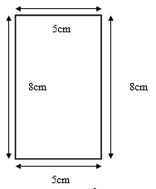
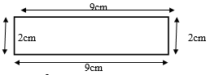 | 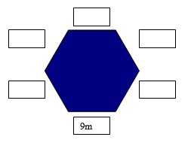
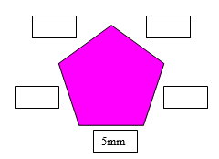 | 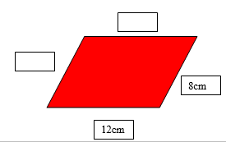
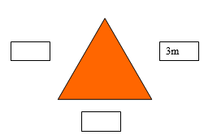 | 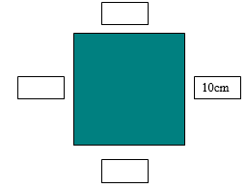

English

Please complete a film review on a film you have watched recently.
What should I include in my film review?
Here is a list of some common things that you see in film reviews. Is there anything extra included in the review? Is there anything missing?
- The film's title.
- An eye-catching heading.
- The genre (type of film).
- The audience. Who is the film for?
- The director, main actors, when it was made, has it won any awards?
- The plot. A brief summary that doesn't mention the ending!
- Your opinion.
- Your evaluation.
Example:
Bend it Like Beckham – Brilliant and Funny!
How can I describe Bend It Like Beckham? If I had to choose a genre, I would say it’s a romantic comedy-drama sports film!
The film was made in 2002 and directed by Gurinder Chandha who is well-known for films which explore the lives of Indians living in the UK.
The film is set in London and stars Jess (Parminder Naghra), who is an 18-year-old girl with Indian parents. One of the main storylines is the tension between Jess, who loves football, and her parents, who don’t allow her to play.Jess’s friend and teammate, Jules, who is played by Keira Knightly (Pirates of the Caribbean) encourages Jess to play despite her parent's wishes.
The film deals with serious social problems such as sexism and racism, but the film is very funny at the same time! The acting is very good and of course, there is a happy ending! Oh, and David Beckham is in the movie, but you must wait until the end for that!
I would give Bend It Like Beckham four and a half stars out of five and definitely recommend you watch it!
______________________________________________________________________________________________________________________________________________________________________________________________________________________________________________________________________________________________________________________________________________________________________________________________________________________________________________________________________________________________________________________________________________________________________________________________________________________________________________________________________________________________________________________________________________________________________________________________________________________________________________________________________________________________________________________________________________________________________________________________________________________________________________________________________________________________________________________________________________________________________________________________________________________________________________________________________________________________________________________________________________________________________________________________________________________________________________________________________________________________________________________________________________________________________________________________________________________________________________________________________________________________________________________________________________________________________________________________________________________________________________________________________________________________________________________________________________________________________________________________________________________________________________________________________________________________________________________________________________________________________________________________________________________________________________________________________________________________________________________________________________________________________________________________________

