Hello year 2!
Below are activities that you could complete over the course of a week. Please keep in mind that the tasks below are only suggestions - you can complete as many as you would like at any time. Please connect to ClassDojo where you can stay in touch with your class teacher and also refer to the activities your teacher has posted for you.

Subject | Monday | Tuesday | Wednesday | Thursday | Friday
Reading & Writing | Fact file writing  Choose from a fireman, doctor, bus driver, football coach, nurse and many more! Colour in the picture and then write about how these people help us in our lives.  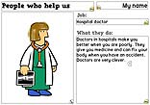  Discussion points:  - What job does your person do?  - How does this person help us?  - What would you like to do when you grow up? | Watch this 5 minute story called Lost and found.  https://www.youtube.com/watch?v=cRAAQ8EWzig  Task: Create a Lost poster  Imagine you’ve lost your pet or something important to you. Design a poster to help find your lost pet/object. Draw your pet/object, write a description and don’t forget to offer a reward.  Discussion points:  - What kind of animal is your pet?  - What kind of object is it?  - What is your pet's name?  - What colour is your pet/object?  - What does it like to eat?  - What does your object do?  - What is unique about your object/pet?  - When was it last seen?  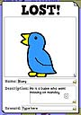 | We have looked at explanation texts last week.  Think about how we grow and change in life.  Look back at some old pictures of you or your adults and think about how you or they have changed.  Can you create a timeline to show the different stages of growth/change and write a short description next to each one.  Use the template below to help you. You could also create your own by using old pictures.  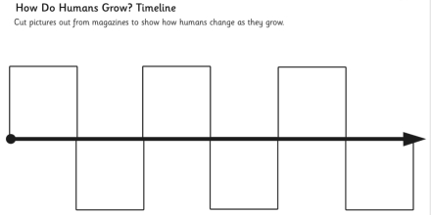 | Write a letter to your teacher about how your feeling during this time.  How are you feeling about returning to school?  What have you missed the most?  Is there anything your worried about?  What are you excited about?  What are you looking forward to the most?  Is there anything you want to tell your teacher that may help you when you return back?  Share your letters on Class dojo with your teacher. | Write a review of a film or TV show that you have watched this week.  What happened?  What was your favourite part?  Would you recommend others to watch it?
Topic-History, Geography, Science & RE  If you are looking for additional writing activities that link to topic lessons, Jane Considine from the Training Space (On YouTube) holds daily writing lessons that you can watch live or on catch up on their YouTube channel. | Science  Did you watch the Space X launch last week?  Nasa astronauts blasted off to the International Space station.  If you missed it, click on the link below to watch it.  https://www.bbc.co.uk/news/av/science-environment-52863779/spacex-launch-nasa-astronauts-blast-off-to-the-international-space-station  What did you think of it?  Why was is special? | History  The difference between rich and poor in Victorian Britain was great. It affected whether or not children went to school., what they wore, what they had to play with and even where they went to the toilet!  Poor children were sometimes called street urchins. Rich families lived in large houses with cooks and maids.  Task: Compare the lives of rich and poor Victorians. | RE  Last week Muslims celebrated Eid.  Research about what Ramadan is and create a poster about it.  Write about the things that happen during Ramadan.  Discussion points:  - Ramadan lasts for the whole of the ninth month of the Islamic calendar  - During Ramadan Muslims do not eat or drink from dawn to sunset  - During Ramadan Muslims remember the poor | PE  What’s your name?  Spell your name and do the activities.  Challenge: Can you do your surname too?  Can you do all the adults in your home?  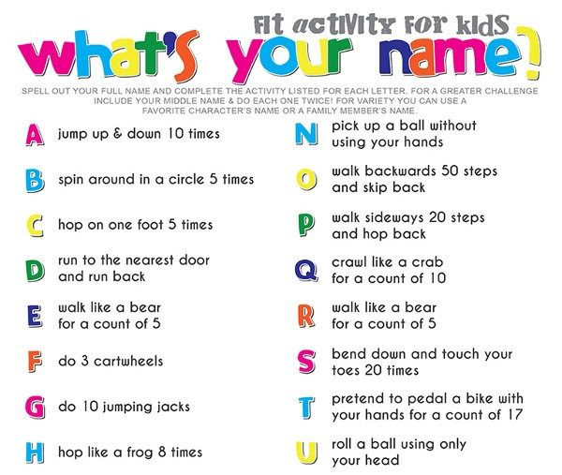 | Cooking  Can you make your very own smoothie?  What did you put in it?  Why did you choose those ingredient?  Share the recipe and photo with your teacher on class dojo.
Maths  The white rose maths hub has plenty of resources that you can access at home for free.  You can access their problem on the day using the link below.  https://whiterosemaths.com/resources/classroom-resources/problems/ | Play one of these maths games each day from this website.  https://matr.org/blog/fun-maths-games-activities-for-kids/  All the instructions can be found on the site. | Can you make some 2D and 3D shapes using materials in your home? Pencils, sticks, straw or even Lego are all great for this challenge! | Create your own Ping Pong maths game!  Have a competition with your family.  Who can get the highest score?  What’s the best technique to shoot the ping pong in the cups?  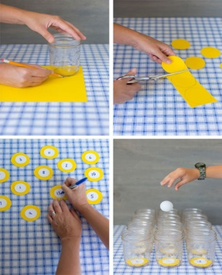 | Can you create your own clock to show us your daily routine.  See below for ideas:  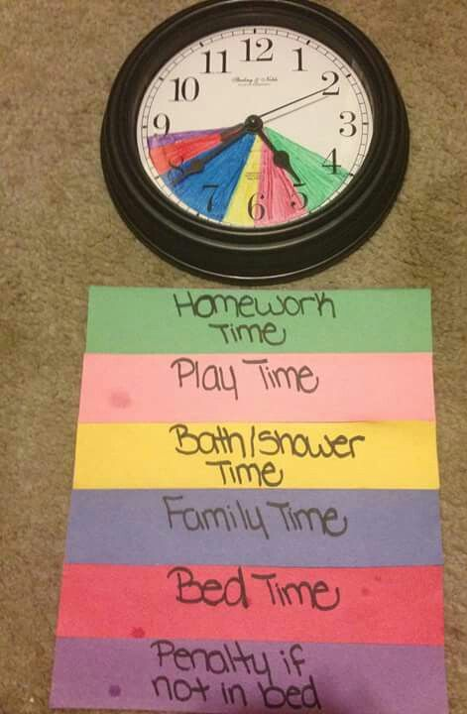 | Complete this timetable wheel.  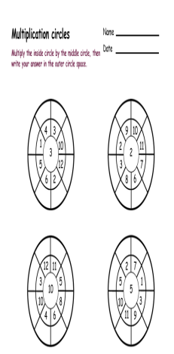
Creative Time | Make something with your family as a memorial of lockdown 2020.  It could be a picture frame, a painting, a craft activity etc.  Keep it for show and tell when we return.  Show your teacher what you made on class dojo. | Create a family tree showing any siblings, parents or carers, grandparents, aunts, uncles and cousins you have.  You can be as creative as you like!  Write some facts about each person! | Here’s a creative competitive game you can play with your family.  Watch the clip on how to make your very own paper helicopter.  https://www.youtube.com/watch?v=5Vk-gXwHDSM  Who can keep their helicopter flying for the longest amount of time? | Task: Get a mirror or a recent picture of yourself.  Filling up a whole A4 piece of paper, carefully draw a self-portrait. Remember all the sketching and shading skills we have already practised. | Task: Create a musical instrument with things you have a home. ( e.g. a shaker)  Record yourself creating a beat!  Have a dance off using your instrument.  Sing a song and play the instrument.

Below are suggested activities that you could be practicing on a regular basis.

Spellings – Keep referring to the year 2 common exception words that you must know how to read and write in year 2.  Keep an eye out for weekly spelling patterns on class dojo. Make sure you have signed up via the email link your teacher has sent you.  You could do any of the following activities:  -Create a word search with your spellings.  -Write silly sentences with your spellings.  -Rainbow spellings  -Write a story that includes each of your spelling words.  -Hold a quiz with the members of your family. | Timestables - knowing our timestables is extremely important, especially your x2, x3, x5, x10’s.  Don’t forget that we also need to know the inverse. E.g. 12 divided by 2 is 6.  Reading- Read a book, magazine, article, leaflet, poster, newspapers. See if you can share what you’ve read with someone else in your family.  Phonics- play on phonics play as it’s a great way to practice your alien words and real words. | Physical Activity - make sure you are trying to be active every day.  - Watch Joe Wicks PE lessons live every day at 9:00am or watch his previous videos at any time of day.  - Create your own circuit and teach it to the members of your family.  - Watch some of the Just Dance videos on YouTube and get dancing for 20 - 30 minutes.  - Have a go at doing some Cosmic Yoga on YouTube

