Q1. Figure 1 shows a reflex in the iris of the human eye in response to changes in light levels.
Figure 1
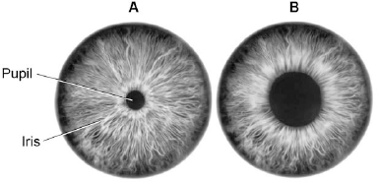
(a) Describe the changes in the pupil and iris going from A to B in Figure 1.
Explain how these changes occur. Refer to the changes in light level in your answer.
________________________________________________________________
_________________________________________________________________
_________________________________________________________________
_________________________________________________________________
_________________________________________________________________
(4)
(b) Some people wear glasses to improve their vision. Figure 2 shows light entering the eye in a person with blurred vision. Figure 3 shows how this condition is corrected with glasses.
Figure 2 Figure 3
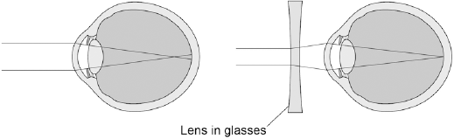
Compare Figure 2 and Figure 3. Explain how the blurred vision is corrected.
_________________________________________________________________
_________________________________________________________________
_________________________________________________________________
_________________________________________________________________
(2)
(Total 6 marks)
Q2. Two students investigated reflex action times. This is the method used.
1. Student A sits with her elbow resting on the edge of a table.
2. Student B holds a ruler with the bottom of the ruler level with the thumb of Student A.
3. Student B drops the ruler.
4. Student A catches the ruler and records the distance, as shown in the diagram below.
5. Steps 1 to 4 were then repeated.
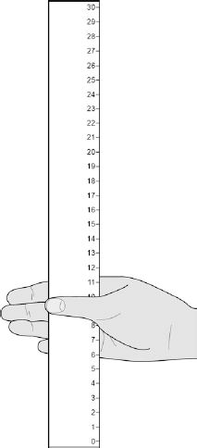
(a) Suggest two ways the students could improve the method to make sure the test would give valid results.
1. _________________________________________________________________
_________________________________________________________________
2. _________________________________________________________________
_________________________________________________________________
(2)
(b) The table below shows Student A’s results.

Test Number | Distance ruler dropped in mm
1 | 117
2 | 120
3 | 115
4 | 106
5 | 123
6 | 125
7 | 106
What is the median result?

Tick one box.
106
115
116
117
123
(1)
(c) The mean distance the ruler was dropped is 116 mm.
Calculate the mean reaction time.
Use the equation:
reaction time in s = 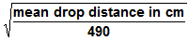
Give your answer to 3 significant figures
_________________________________________________________________
_________________________________________________________________
_________________________________________________________________
Mean reaction time = ______________________ s
(3)

(d) The students then measured Student A’s reaction time using a computer program.
This is the method used.
1. The computer shows a red box at the start.
2. As soon as the box turns green the student has to press a key on the keyboard as fast as possible.
3. The test is repeated five times and a mean reaction time is displayed.
Student A’s mean reaction time was 110 ms.
Using a computer program to measure reaction times is likely to be more valid than the method using a dropped ruler.
Give two reasons why.
1. _________________________________________________________________
_________________________________________________________________
2. _________________________________________________________________
_________________________________________________________________
(2)
(e) A woman has a head injury. Her symptoms include:
• finding it difficult to name familiar objects
• not being able to remember recent events.
Suggest which part of her brain has been damaged.
_________________________________________________________________
(1)
(f) A man has a head injury.
He staggers and sways as he walks.
Suggest which part of his brain has been damaged.
_________________________________________________________________
(1)
(Total 10 marks)
Q3. Two students investigated reflex action times. This is the method used.
1. Student A sits with his elbow resting on the edge of a table.
2. Student B holds a ruler with the bottom of the ruler level with the thumb of Student A.
3. Student B drops the ruler.
4. Student A catches the ruler and records the distance.
5. Steps 1 to 4 are then repeated.
The same method was also used with Student A dropping the ruler and Student B catching the ruler.
(a) Give two variables the students controlled in their investigation.
1. _________________________________________________________________
2. _________________________________________________________________
(2)
(b) Figure 1 shows one of the results for the Student A.
Figure 1
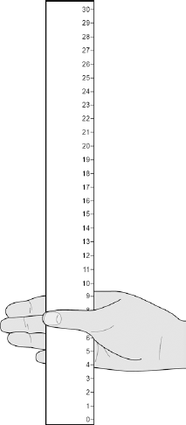
What is the reading shown in Figure 1?
_________________________________________________________________
Reading on ruler = ___________________________ cm
(1)

(c) Table 1 shows the students’ results.
Table 1

Test  number | Distance ruler dropped in cm
 | Student A | Student B
1 | 9 | 12
2 | 2 | 13
3 | 6 | 13
4 | 7 | 9
5 | 7 | 8
Mean | 7 | X
Circle the anomalous result in Table 1 for Student A.
(1)
(d) What is the median result for Student B?

Tick one box.
8
11
12
13
(1)
(e) Calculate the value of X in Table 1.
_________________________________________________________________
Mean distance ruler dropped = __________________ cm
(1)
(f) Figure 2 shows the scale used to convert distance of the ruler drop to reaction time.
Figure 2
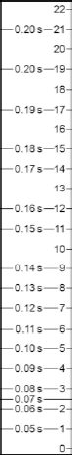
Calculate how much faster the reaction time of Student A was compared to Student B. Use Figure 2 and Table 1.
_________________________________________________________________
Answer = _____________ s
(2)
(g) What improvement could the students make to the method so the results are more valid?

Tick one box.
Use alternate hands when catching the ruler
Carry out more repeats
Use a longer ruler for catching
Use more than two students to collect results
(1)
(h) Student A carried out a second investigation to see the effect of caffeine on the reflex action. Table 2 shows his results.
Table 2

Test number | Distance ruler dropped in cm
 | Without caffeine | With caffeine
1 | 9 | 5
2 | 6 | 5
3 | 9 | 4
4 | 6 | 7
5 | 10 | 4
Mean | 8 | 5
Give one conclusion about the effect of caffeine on reflex actions.
_________________________________________________________________
_________________________________________________________________
(1)
(Total 10 marks)
Q4. Homeostasis controls the internal conditions of the body.
(a) Explain how blood glucose levels are controlled in the body of someone who does not have diabetes.
_________________________________________________________________
_________________________________________________________________
_________________________________________________________________
_________________________________________________________________
_________________________________________________________________
_________________________________________________________________
(4)
(b) Compare how each type of diabetes is caused. Suggest how each type of diabetes can be treated.
_________________________________________________________________
_________________________________________________________________
_________________________________________________________________
_________________________________________________________________
_________________________________________________________________
_________________________________________________________________
(4)
(c) Look at the table below.

Population of UK in 2015 | 6.5 × 10⁷
Number of people diagnosed with diabetes | 3.45 × 10⁶
Estimated number of people with undiagnosed diabetes | 5.49 × 10⁵
Calculate the percentage (%) of the UK population estimated to have diabetes.
You should include both diagnosed and undiagnosed people in your calculation.
Give your answer to 2 significant figures.
_________________________________________________________________
_________________________________________________________________
_________________________________________________________________
_________________________________________________________________
_________________________________________________________________
Estimated percentage of population with diabetes = ___ %
(3)
(d) A urine test can be used to check for the presence of glucose in the urine. Diabetes can also be diagnosed with a blood test to measure the concentration of blood glucose. Suggest why a blood test is more reliable than a urine test.
_________________________________________________________________
_________________________________________________________________
(1)
(e) A blood test called the glucose tolerance test checks how well the body processes glucose. Concentrations of glucose in the blood are measured before and after drinking a glucose drink.
Patients are not allowed to eat food for 8 hours before the glucose tolerance test.
Suggest why patients are not allowed to eat for 8 hours before the test.
_________________________________________________________________
_________________________________________________________________
(1)

(f) The diagram below shows the results of a glucose tolerance test for two patients, A and B.
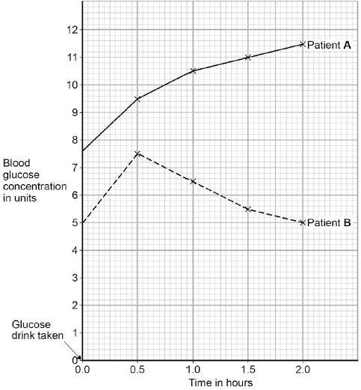
Which patient has diabetes? Justify your answer.
Patient _____________
Justification _______________________________________________________
_________________________________________________________________
_________________________________________________________________
(2)
(Total 15 marks)
Q5. The diagram shows some of the stages in IVF (in vitro fertilisation).
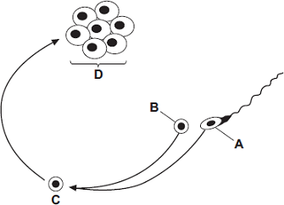
(a) Use words from the box to name structures A, B, C and D.

 | egg | embryo | fertilised egg | ovary | sperm
Structure A ____________________________
Structure B ____________________________
Structure C ____________________________
Structure D ____________________________
(4)
(b) What do doctors do next with structure D?
_________________________________________________________________
_________________________________________________________________
_________________________________________________________________
(2)
(c) The table gives statistics for an IVF clinic.

 | Age of women treated
 | Below 35  years | 35 – 37  years | 38 – 39  years | 40 – 42  years
Number of women treated | 414 | 207 | 106 | 53
Number of women who  produced one baby | 90 | 43 | 17 | 1
Number of women who  produced twins | 24 | 8 | 4 | 1
Number of women who  produced triplets | 1 | 0 | 0 | 0
(i) About what proportion of the treated women aged 35 – 37 years produced one or more babies? Draw a ring around your answer.
one quarter one third half
(1)

(ii) This clinic does not give IVF treatment to women over 42 years of age.
Use data from the table to explain why.
_____________________________________________________________
_____________________________________________________________
_____________________________________________________________
_____________________________________________________________
(2)
(iii) The committee which regulates IVF treatment now advises that only one embryo is used in each treatment. Suggest one reason for this.
_____________________________________________________________
_____________________________________________________________
(1)
(Total 10 marks)
Q6. In this question you will be assessed on using good English, organising information clearly and using specialist terms where appropriate.
The human body is kept at a constant internal temperature of about 37 °C.
Body temperature is monitored and controlled by the thermoregulatory centre in the brain.
Describe what happens in the body to keep the body temperature constant.
_____________________________________________________________________
_____________________________________________________________________
_____________________________________________________________________
_____________________________________________________________________
_____________________________________________________________________
_____________________________________________________________________
_____________________________________________________________________
_____________________________________________________________________
_____________________________________________________________________
_____________________________________________________________________
_____________________________________________________________________
_____________________________________________________________________
_____________________________________________________________________
(Total 6 marks)
Q7. The diagram below shows the pathway for a simple reflex action.
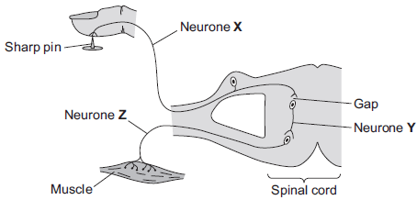
(a) What type of neurone is neurone X?
Draw a ring around the correct answer.
motor neurone relay neurone sensory neurone
(1)
(b) There is a gap between neurone X and neurone Y.
(i) What word is used to describe a gap between two neurones?
Draw a ring around the correct answer.
effector receptor synapse
(1)
(ii) Draw a ring around the correct answer to complete the sentence.

Information passes across the gap as | a chemical.  an electrical impulse.  pressure.
(1)
(c) Describe what happens to the muscle when it receives an impulse from neurone Z. How does this reflex action help the body?
What happens to the muscle ___________________________________________
_________________________________________________________________
How this helps the body _______________________________________________
_________________________________________________________________
(2)
(Total 5 marks)

Q8. The diagram below shows how a nerve impulse passing along a relay neurone causes an impulse to be sent along another type of neurone, neurone X.
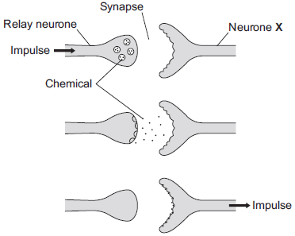
(a) What type of neurone is neurone X?
_________________________________________________________________
(1)
(b) Describe how information passes from the relay neurone to neurone X.
Use the diagram to help you.
_________________________________________________________________
_________________________________________________________________
_________________________________________________________________
_________________________________________________________________
(3)
(c) Scientists investigated the effect of two toxins on the way in which information passes across synapses. The table below shows the results.

Toxin | Effect at the synapse
Curare | Decreases the effect of the chemical on neurone X
Strychnine | Increases the amount of the chemical made in the relay neurone
Describe the effect of each of the toxins on the response by muscles.
Curare _____________________________________________________________
_________________________________________________________________
Strychnine __________________________________________________________
_________________________________________________________________
(2)
(Total 6 marks)
Q9. This question is about the nervous system.
(a) Describe the difference between the function of a receptor and the function of an effector. In your answer you should give one example of a receptor and one example of an effector.
_________________________________________________________________
_________________________________________________________________
_________________________________________________________________
_________________________________________________________________
_________________________________________________________________
_________________________________________________________________
(4)
(b) Synapses are important in the nervous system.
(i) What is a synapse?
_____________________________________________________________
_____________________________________________________________
_____________________________________________________________
_____________________________________________________________
(2)
(ii) Describe how information passes across a synapse.
_____________________________________________________________
_____________________________________________________________
_____________________________________________________________
_____________________________________________________________
(2)
(c) Reflexes may be co-ordinated by the brain or by the spinal cord.
(i) The reflexes from sense organs in the head are co-ordinated by the brain.
Name a sense organ involved in a reflex co-ordinated by the spinal cord.
_____________________________________________________________
(1)
(ii) The table shows information about reflexes co-ordinated by the brain and reflexes co-ordinated by the spinal cord.

Organ co-ordinating the reflex | Mean length of neurones involved in cm | Mean time taken for reflex in milliseconds | Mean speed of impulse in cm per millisecond
Brain | 12 | 4 | 3
Spinal cord | 80 | 50
Calculate the mean speed of the impulse for the reflex co-ordinated by the spinal cord.
_____________________________________________________________
_____________________________________________________________
Mean speed = ________ cm per millisecond
(1)
(iii) In reflexes co-ordinated by the brain there are no relay neurones.
Suggest why there is a difference in the mean speed of the impulse for the two reflexes.
_____________________________________________________________
_____________________________________________________________
_____________________________________________________________
_____________________________________________________________
(2)
(Total 12 marks)
Q10. Endocrine glands produce hormones.
(a) Hyperthyroidism is caused by an overactive thyroid gland. Suggest what would happen in the body of a person with hyperthyroidism.
_________________________________________________________________
_________________________________________________________________
_________________________________________________________________
_________________________________________________________________
(3)
(b) Describe the roles of FSH and LH in the menstrual cycle.
_________________________________________________________________
_________________________________________________________________
_________________________________________________________________
(2)
(c) The combined pill is a contraceptive that contains progesterone and oestrogen.
The ‘mini-pill’:
• is a contraceptive that only contains the progesterone hormone
• has to be taken at the same time each day to prevent pregnancy.
The success rate of the mini-pill in preventing pregnancy is lower than that of the combined pill.
Explain why missing a dose of the mini-pill would reduce the success rate of the mini-pill.
_________________________________________________________________
_________________________________________________________________
_________________________________________________________________
_________________________________________________________________
_________________________________________________________________
_________________________________________________________________
_________________________________________________________________
_________________________________________________________________
(4)
(Total 9 marks)
Q11. Humans use the nervous system to react to changes in the environment.
(a) (i) Which word means a change in the environment? Draw a ring around the correct answer.

neurone | reflex | stimulus
(1)
(ii) Figure 1 shows a light receptor cell.
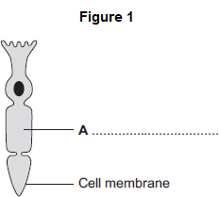
Use the correct answer from the box to label part A on Figure 1.

chloroplast | cytoplasm | vacuole
(1)
(b) Figure 2 shows a boy riding a bicycle on a sunny day.
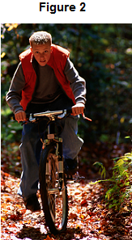
(i) Receptors in the boy’s body detect changes in the environment.
Complete the table to show which organ of the body contains the receptors for each change in the environment.

Change in the environment | Organ that contains the receptors
Sound of traffic from behind him
Flashing blue lights of a police car
Cooler air temperature in the shadows
(3)
(ii) The boy’s response to danger is to pull on the bicycle brakes. Which type of effector causes this response? Tick () one box.

A gland
A muscle
A synapse
(1)
(Total 6 marks)
Q12. This question is about hormones.
(a) (i) Hormones carry messages.
What type of messenger is a hormone?
Draw a ring around the correct answer.

chemical | electrical | environmental
(1)
(ii) Which part of the brain secretes hormones?
Draw a ring around the correct answer.

cerebellum | medulla | pituitary gland
(1)
(b) Figure 1 shows the level of a pregnancy hormone over a 40-week pregnancy.
This hormone can be detected in a pregnancy test.
Figure 1
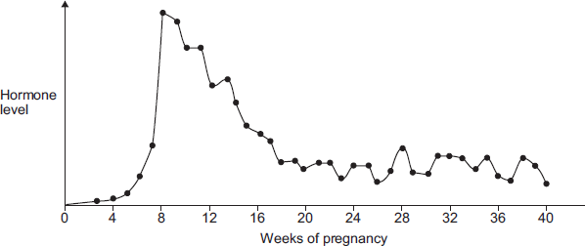
A woman takes a pregnancy test.
In which week of pregnancy is the test most likely to give a positive result?
Use information from Figure 1.
Write the correct answer in the box.
(1)
(c) Figure 2 shows the levels of three other hormones during pregnancy.
The baby is usually born at about 40 weeks.
Figure 2
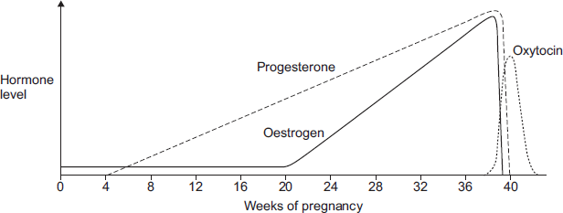
Adaptation by kind permission of Biozone International
(i) Describe the patterns in the levels of oestrogen and progesterone from 0 to 36 weeks.
_____________________________________________________________
_____________________________________________________________
_____________________________________________________________
_____________________________________________________________
_____________________________________________________________
_____________________________________________________________
(4)
(ii) Which hormone is likely to stimulate contractions of the uterus (womb) when the baby is born? Use information from Figure 2 to give a reason for your answer.
_____________________________________________________________
_____________________________________________________________
_____________________________________________________________
_____________________________________________________________
(2)
(Total 9 marks)
Q13. Hormones are involved in controlling the menstrual cycle and fertility.
(a) (i) Use the correct answer from the box to complete the sentence.

auxin follicle stimulating hormone (FSH) thalidomide
A hormone produced by the pituitary gland is ____________________
(1)
(ii) Use the correct answer from the box to complete the sentence.

luteinising hormone (LH) oestrogen statin
A hormone produced by the ovaries is ___________________________
(1)
(b) (i) Why are fertility drugs given to some women?
_____________________________________________________________
_____________________________________________________________
(1)
(ii) A doctor injects fertility drugs into a woman. After the injection, the hormones travel to the woman’s ovaries. How do the hormones travel to the ovaries?
Draw a ring around the correct answer.

through the bloodstream | through the neurones | through the skin
(1)
(c) Which two hormones are used in contraceptive pills? Tick (✔) two boxes.

FSH |  |  | oestrogen
LH |  |  | progesterone
(2)
(Total 6 marks)
Q14. (a) Which organ of the human body produces egg cells?
Draw a ring around the correct answer.
liver ovary testis
(1)
(b) An egg joins with a sperm and develops into an embryo.
How many chromosomes are there in each cell of a human embryo?
Draw a ring around the correct answer.
23 46 48
(1)

(c) Some women find it difficult to have a baby. A doctor may suggest that these women should use In Vitro Fertilisation (IVF) to help them have a baby.
Table 1 shows how successful IVF was for women of different ages at one clinic.
Table 1

Age of women in years | Percentage of women who had a baby
<35 | 35
35–37 | 31
38–39 | 25
40–42 | 32
43–44 | 7
>44 | 0
(i) A student thought that the result for women aged 40–42 was anomalous.
Suggest why the student thought this result was anomalous.
_____________________________________________________________
_____________________________________________________________
(1)
(ii) Describe the general trend in the results in Table 1. You should ignore the anomalous result.
_____________________________________________________________
_____________________________________________________________
(1)
(d) Some babies are born with a faulty chromosome. Scientists investigated whether the chance of having a baby with a faulty chromosome is also related to the age of the woman.
Table 2 shows the scientists’ results.
Table 2

Age of women in years | Number of women per 1000 who had a baby with a faulty chromosome
25 | 2.0
30 | 2.6
35 | 6.1
40 | 19.6
45 | 66.0
(i) A 45-year-old woman is more likely than a 25-year-old woman to have a baby with a faulty chromosome.
How many times more likely?
_____________________________________________________________
_____________________________________________________________
Answer = _____________________ times
(2)
(ii) Suggest two reasons why many fertility clinics will not accept women over 40 years of age for IVF treatment. Use information from Table 1 and Table 2 in your answer.
1. ____________________________________________________________
_____________________________________________________________
2. ____________________________________________________________
_____________________________________________________________
(2)
(Total 8 marks)

Q1. Figure 1 shows an image of a small section of DNA.
Figure 2 shows the structure of a small section of DNA.
Figure 1 Figure 2
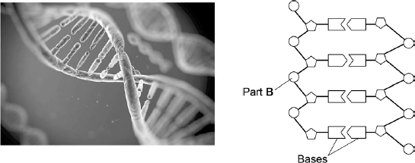
(a) What is Part B?
______________________________________________________
______________________________________________________
(1)
(b) In Figure 1 the structure of DNA shows four different bases.
There are four different bases and they always pair up in the same pairs. Which bases pair up together?
______________________________________________________
(1)
(c) Syndrome H is an inherited condition. People with syndrome H do not produce the enzyme IDUA.
Figure 3 shows part of the gene coding for the enzyme IDUA.
Figure 3
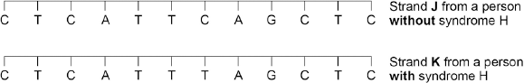
Strand K shows a mutation in the DNA which has caused syndrome H. The enzyme IDUA helps to break down a carbohydrate in the human body. The enzyme IDUA produced from Strand K will not work.
Explain how the mutation could cause the enzyme not to work.
______________________________________________________
______________________________________________________
______________________________________________________
______________________________________________________
______________________________________________________
______________________________________________________
______________________________________________________
______________________________________________________
______________________________________________________
(5)
(d) A recessive allele causes syndrome H. A heterozygous woman and a homozygous recessive man want to have a child.
Draw a Punnett square diagram to determine the probability of the child having syndrome H. Identify any children with syndrome H.Use the following symbols:
A = dominant allele
a = recessive allele
Probability = ___________________ %
(5)
(Total 12 marks)
Q2. Polydactyly is an inherited condition caused by a dominant allele.
- The figure below shows the hand of a man with polydactyly. The man has an extra finger on each hand. The man’s mother also has polydactyly but his father does not.

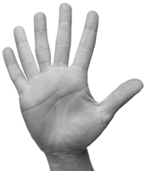
(i) The man is heterozygous for polydactyly. Explain how the information given above shows that the man is heterozygous for polydactyly.
__________________________________________________
__________________________________________________
__________________________________________________
__________________________________________________
(3)
(ii) The man marries a woman who does not have polydactyly. What is the probability that their first child will have polydactyly?
__________________________________________________
(1)
(b) The man has red hair. His sister has brown hair. Both of their parents have brown hair. Complete the genetic diagram below to show how the man’s parents were able to have some children with red hair and some with brown hair.
Brown hair is caused by the dominant allele, B.
Red hair is caused by a recessive allele, b.

 | Father | Mother
Parental phenotypes | _________________ | _________________
Parental Genotypes | _________________ | _________________
Gametes | ________ ________ | ________ ________
Offspring genotypes: _____________________________________________
Offspring phenotypes: ____________________________________________
(5)
(Total 9 marks)
Q3. In humans, hair colour is an inherited characteristic. Red hair is caused by a recessive allele.
(a) When does a recessive allele control the development of a characteristic?

Tick (✔) one box.
When the allele is present on only one of the chromosomes.
When the dominant allele is not present.
When the allele is inherited from the female parent.
(1)
(b) Figure 1 shows the inheritance of hair colour in one family.
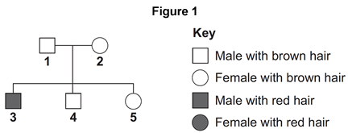
(i) Brown hair is caused by a dominant allele, B.
Red hair is caused by the recessive allele, b.
What combination of alleles does person 1 have?

Tick (✔) one box.
BB
Bb
bb
(1)
(ii) Person 3 married a woman with brown hair. Figure 2 shows how hair colour could be inherited by their children.
Figure 2
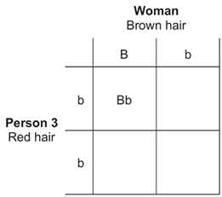
Complete Figure 2 to show the combination of alleles that the children would inherit. One has been done for you.
(2)
(iii) What is the probability that one of the children would have red hair?

Tick (✔) one box.
1 in 2
1 in 3
1 in 4
(1)
(Total 5 marks)
Q4. Our understanding of genetics and inheritance has improved due to the work of many scientists.
(a) Draw one line from each scientist to the description of their significant work.

Scientist |  | Description of significant work
Carried out breeding experiments
on pea plants.
Charles Darwin
 |  | Wrote 'On the origin of species'.
Alfred Russel Wallance
 |  | Worked on plant defence systems.
Gregor Mendel
 |  | Worked on warning colouration in animals.
(3)
(b) In the mid-20th century the structure of DNA was discovered.
What is a section of DNA which codes for one specific protein called?
______________________________________________________
(1)
(c) Figure 1 shows one strand of DNA.
The strand has a sequence of bases (A, C, G and T).
Figure 1
How many amino acids does the strand of DNA in Figure 1 code for?

Tick one box.
2
3
4
6
(1)
(d) Mutations of DNA cause some inherited disorders. One inherited disorder is cystic fibrosis (CF). A recessive allele causes CF. Complete the genetic diagram in
Figure 2.
• Identify any children with CF.
• Give the probability of any children having CF.
Each parent does not have CF. The following symbols have been used:
D = dominant allele for not having CF
d = recessive allele for having CF
Figure 2
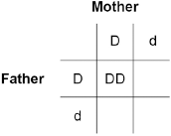
Probability of a child with CF = _____________________
(3)
(e) What is the genotype of the mother shown in Figure 2?

Tick one box.
Heterozygous
Homozygous dominant
Homozygous recessive
(1)
(Total 9 marks)
Q5. Humans reproduce sexually.
(a) Draw a ring around the correct answer to complete each sentence.

 |  | chromosomes
(i) | At fertilisation | genes | join together.
 |  | gametes
(1)
 |  | chromosomes.
(ii) | At fertilisation a single cell forms. The cell has new pairs of | nuclei.
 |  | gametes.
(1)
(b) A child inherits cystic fibrosis. The child’s parents do not have cystic fibrosis.
(i) What does this information tell us about the cystic fibrosis allele? Tick () one box.

The allele is dominant.
The allele is recessive.
The allele is strong.
(1)
(ii) How many copies of the cystic fibrosis allele does the child have?
Draw a ring around your answer.

one | two | four
(1)
(c) The diagram shows a human body cell. Which part of the cell, A, B, C or D:

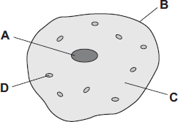
(i) contains the allele for cystic fibrosis
(1)
(ii) is affected by cystic fibrosis?
(1)
(Total 6 marks)
Q6. Figure 1 shows a human body cell.
Figure 1
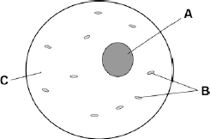
(a) Which part in Figure 1 contains chromosomes? Tick one box.

A |  |  | B |  |  | C
(1)
(b) Humans have pairs of chromosomes in their body cells.
Draw one line from each type of cell to the number of chromosomes it contains.
Type of cell |  | Number of Chromosomes

 |  | 10
Human body cell |  | 23
 |  | 46
Sperm cell |  | 60
 |  | 92
(2)
(c) Humans have two different sex chromosomes, X and Y. Figure 2 shows the inheritance of sex in humans.
Figure 2
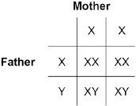
Circle a part of Figure 2 that shows an egg cell.
(1)
(d) Give the genotype of male offspring.
______________________________________________________
(1)
(e) A man and a woman have two sons. The woman is pregnant with a third child. What is the chance that this child will also be a boy?

Tick one box.
0%
25%
50%
100%
(1)
(Total 6 marks)
Q7.(a) Mr and Mrs Smith both have a history of cystic fibrosis in their families.
Neither of them has cystic fibrosis. Mr and Mrs Smith are concerned that they may have a child with cystic fibrosis. Use a genetic diagram to show how they could have a child with cystic fibrosis. Use the symbol A for the dominant allele and the symbol a for the recessive allele.

(3)
(b) Mr and Mrs Smith decided to visit a genetic counsellor who discussed embryo screening. Read the information which they received from the genetic counsellor.

• Five eggs will be removed from Mrs Smith's ovary while she is under an anaesthetic.
• The eggs will be fertilised in a dish using Mr Smith’s sperm cells.
• The embryos will be grown in the dish until each embryo has about thirty cells.
• One cell will be removed from each embryo and tested for cystic fibrosis.
• A suitable embryo will be placed into Mrs Smith’s uterus and she may become pregnant.
• Any unsuitable embryos will be destroyed.
(i) Suggest why it is helpful to take five eggs from the ovary and not just one egg.
__________________________________________________
__________________________________________________
(1)
(ii) Evaluate the use of embryo screening in this case. Remember to give a conclusion to your evaluation.
__________________________________________________
__________________________________________________
__________________________________________________
__________________________________________________
__________________________________________________
__________________________________________________
__________________________________________________
__________________________________________________
__________________________________________________
__________________________________________________
(4)
(c) In someone who has cystic fibrosis the person’s mucus becomes thick. The diagram shows how, in a healthy person, cells at the lung surface move chloride ions into the mucus surrounding the air passages.
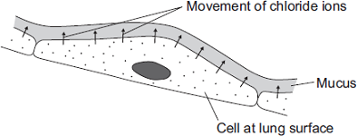
The movement of chloride ions causes water to pass out of the cells into the mucus. Explain why.
______________________________________________________
______________________________________________________
______________________________________________________
______________________________________________________
______________________________________________________
______________________________________________________
______________________________________________________
(3)
(Total 11 marks)
Q8. When humans reproduce, chromosomes and genes are passed on to the next generation. In each of the following questions, draw a ring around the correct answer to complete the sentence.

 |  |  | cellulose.
 | (a) | A gene is a small section of | DNA.
 |  |  | protein.
(1)
 |  |  | X and X.
 | (b) | The sex chromosomes in the human male are | X and Y.
 |  |  | Y and Y.
(1)
 |  |  | 23 chromosomes.
 | (c) (i) | Most human body cells contain | 46 chromosomes.
 |  |  | 92 chromosomes.
(1)
(ii) The number of chromosomes in a human gamete (sex cell)

 |  | the same number as
 | is | half the number | in body cells.
 |  | twice the number
(1)
 |  |  | fertilisation.
 | (d) | Gametes are produced by | meiosis.
 |  |  | mitosis.
(1)
(Total 5 marks)
Q9. DNA is the genetic material of human cells. Figure 1 shows the structure of part of a DNA molecule.
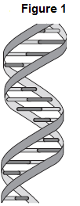
(a) (i) Describe where DNA is found in a human cell.
__________________________________________________
__________________________________________________
__________________________________________________
(2)
(ii) When a cell divides by mitosis the new cells are genetically identical. What causes the cells to be genetically identical?
__________________________________________________
__________________________________________________
(1)
(b) Many genes have different forms called alleles.
(i) A person has polydactyly (extra fingers or toes). Polydactyly is caused by a dominant allele. What is the smallest number of copies of the dominant allele for polydactyly that could be found in a body cell of this person?
______________
(1)
(ii) Another person has cystic fibrosis. Cystic fibrosis (CF) is caused by a recessive allele. How many copies of the recessive CF allele are there in a body cell of this person?
______________
(1)
(c) A burglar broke into a house. The burglar cut his hand on some broken glass. Scientists extracted DNA from the blood on the broken glass. The scientists analysed the DNA from the glass and DNA from three suspects, A, B and C. The scientists used a method called DNA fingerprinting.
Figure 2 shows the scientists’ results.
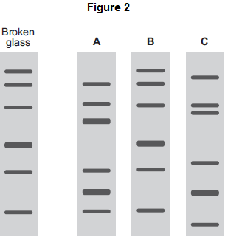
Which suspect, A, B or C, is most likely to have been the burglar?
Tick () one box.

A
B
C
(1)
(Total 6 marks)
Q10. The diagram shows part of a DNA molecule.
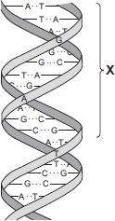
(a) (i) In which part of an animal cell is DNA found?
__________________________________________________
(1)
(ii) Complete the following sentence. The letters A, C, G and T in the diagram represent four different compounds called __________________________ .
(1)
(iii) One strand of the DNA, in the section labelled X, contains the following sequence of these compounds:
T A T G G G T C T T C G
How many amino acids would this section of the DNA code for?
(1)
(iv) The section of DNA described in part (a) (iii) is a small part of a gene. The sequence of compounds A, C, G and T in the gene is important. Explain why.
__________________________________________________
__________________________________________________
__________________________________________________
(2)
(b) Read the following information about genetic engineering.
The caterpillar of the European Corn Borer moth feeds on the fruits of maize (sweet corn). There is a chemical called Bt-toxin which is poisonous to the corn borer caterpillar but not to humans. Scientists carried out the following steps.
1. The Scientists made a bacterial plasmid to which they added two genes:
• Bt gene, which coded for production of the Bt-toxin
• kan^{r} gene, which coded for resistance to an antibiotic called kanamycin.
2. They used this plasmid to produce genetically modified bacteria which could invade plant cells.
3. They mixed these genetically modified bacteria with pieces cut from maize leaves.
4. They placed the pieces of maize leaf on agar jelly in a Petri dish. The agar jelly contained the antibiotic, kanamycin. The kanamycin killed most of the pieces of maize leaf, but a few survived.
5. They took some cells from the surviving pieces of maize leaf and grew them in tissue culture. The result was maize plants that now contained the Bt gene, as well as the kan^{r} gene, in all of their cells.
(i) What is a plasmid (Step 1)?
__________________________________________________
__________________________________________________
__________________________________________________
(2)
(ii) Why did the scientists add kanamycin to the agar jelly (Step 4)?
__________________________________________________
__________________________________________________
__________________________________________________
(2)
(iii) The scientists grew each Bt-maize plant from a single cell which contained the Bt gene. Explain why all the cells in the Bt-maize plant contained the Bt gene.
__________________________________________________
__________________________________________________
__________________________________________________
(2)
(iv) Kanamycin is an antibiotic. Some scientists are concerned that the gene for kanamycin resistance has been put into maize. Suggest why.
__________________________________________________
__________________________________________________
__________________________________________________
(2)
(Total 13 marks)
Q11. In 1866, Gregor Mendel published the results of his investigations into inheritance in garden pea plants.The diagram below shows the results Mendel obtained in one investigation with purple-flowered and white-flowered pea plants.
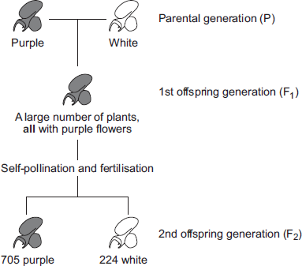
(a) (i) Calculate the ratio of purple-flowered plants to white-flowered plants in the F₂ generation.
Ratio of purple : white = ________________________
(1)
(ii) There was a total of 929 plants in the F₂ generation. Mendel thought that the production of a large number of offspring plants improved the investigation. Explain why.
__________________________________________________
__________________________________________________
__________________________________________________
__________________________________________________
(2)
(b) (i) Some of the plants in the diagram are homozygous for flower colour and some are heterozygous. Complete the table to show whether each of the plants is homozygous or heterozygous. For each plant, tick () one box.

 | Homozygous | Heterozygous
Purple-flowered plant in the P generation
White-flowered plant in the P generation
Purple-flowered plant in the F₁ generation
(2)
(ii) Draw a genetic diagram to show how self-pollination of the F₁ purple-flowered plants produced mainly purple-flowered offspring in the F₂ generation together with some white-flowered offspring. Use the following symbols:
N = allele for purple flower colour
n = allele for white flower colour
(3)
(c) When Mendel published his work on genetics, other scientists at the time did not realise how important it was. Suggest two reasons why.
1. ______________________________________________________
2. ______________________________________________________
(2)
(Total 10 marks)
Q1. The diagram below shows a food chain in a garden.
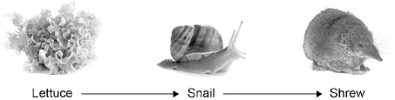

(a) Name one consumer shown in the diagram above.
______________________________________________________
(1)
(b) Name one carnivore shown in the diagram above.
______________________________________________________
(1)
(c) A disease kills most of the shrews in the garden. Suggest why the number of snails in the garden may then increase.
______________________________________________________
______________________________________________________
(1)
(d) What is the name given to all the snails in the garden shown in the diagram above?

Tick one box.
Community
Ecosystem
Population
Territory
(1)
(e) Which pyramid of biomass is correct for the food chain shown in the diagram above? Tick one box.
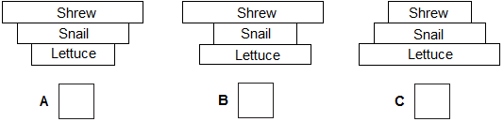
(1)
(f) Some snails ate some lettuces. The lettuces contained 11 000 kJ of energy. Only 10% of this energy was transferred to the snails. Calculate the energy transferred to the snails from the lettuces.
______________________________________________________
Energy = ________________________________ kJ
(1)
(g) Give one reason why only 10% of the energy in the lettuces is transferred to the snails.

Tick one box.
The lettuces carry out photosynthesis
The snails do not eat the roots of the lettuces
Not all parts of a snail can be eaten
(1)
(h) Abiotic factors can affect the food chain. Wind direction is one abiotic factor. Name one other abiotic factor.
______________________________________________________
(1)
(Total 8 marks)
Q2. A student was asked to estimate how many clover plants there are in the school field.The image below shows the equipment used.
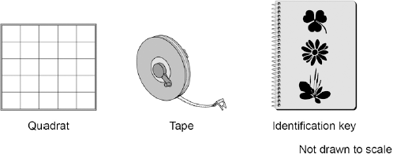
This is the method used.
1. Throw a quadrat over your shoulder.
2. Count the number of clover plants inside the quadrat.
3. Repeat step 1 and step 2 four more times.
4. Estimate the number of clover plants in the whole field.
(a) What is the tape in the image above used for in this investigation?
______________________________________________________
______________________________________________________
(1)
(b) The teacher told the student that throwing the quadrat over his shoulder was not random. The method could be improved to make sure the quadrats were placed randomly. Suggest one change the student could make to ensure the quadrats were placed randomly.
______________________________________________________
______________________________________________________
(1)
(c) How could the student improve the investigation so that a valid estimate can be made?

Tick two boxes.
Weigh the clover plants
Compare their results with another student’s results
Count the leaves of the clover plants
Place more quadrats
Place the quadrats in a line across the field
(2)
(d) The table below shows the student’s results.

Quadrat number | Number of clover plants counted
1 | 11
2 | 8
3 | 11
4 | 9
5 | 1
Total | 40
The area of the school field was 500 m². The quadrat used in the table above had an area of 0.25 m². Calculate the estimated number of clover plants in the school field.
______________________________________________________
______________________________________________________
______________________________________________________
Estimated number of clover plants = _________________
(3)
(e) What was the mode for the results in the table above?

Tick one box.
1
8
11
40
(1)
(f) Suggest which quadrat could have been placed under the shade of a large tree.
Give one reason for your answer.
Quadrat number ___________________
Reason ______________________________________________________
______________________________________________________
(1)
(Total 9 marks)

Q3.A student plans an investigation using mould.
(a) Mould spores are hazardous. Give one safety precaution the student should take when doing this investigation.
______________________________________________________
______________________________________________________
(1)
(b) A student made the following hypothesis about the growth of mould:
‘The higher the temperature, the faster the growth of mould’.
The student planned to measure the amount of mould growing on bread.The student used the following materials and equipment:
• slices of bread
• sealable plastic bags
• a knife
• a chopping board
• mould spores.
Describe how the materials and equipment could be used to test the hypothesis.
______________________________________________________
______________________________________________________
______________________________________________________
______________________________________________________
______________________________________________________
(4)
(c) Give one variable the student should control in the investigation.
______________________________________________________
(1)
(d) Another student did a similar investigation. The diagram below shows the results.
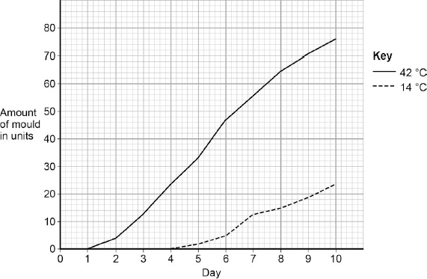
Determine the rate of mould growth at 42 °C between day 2 and day 7.
______________________________________________________
______________________________________________________
Rate of mould growth = _______________ units per day
(2)
(e) The growth of mould shows decomposition of the bread. Give a conclusion about decomposition from the results in the diagram above.
______________________________________________________
______________________________________________________
(1)
(Total 9 marks)
Q4. Students investigated a food chain in a garden.
lettuce → snail → thrush (bird)
The students:
• estimated the number of lettuce plants in the garden
• estimated the number of snails feeding on the lettuces
• counted two thrushes in the garden in 5 hours.
The table below shows the students’ results and calculations.

Organism | Population size | Mean mass of each organism  in g | Biomass of population  in g | Biomass from previous organism that is lost in g | Percentage of biomass lost
Lettuce | 50 | 120.0 | 6000
Snail | 200 | 2.5 | 500 | 5500 | 91
Thrush | 2 | 85.0 | 170 | 330 | 66
(a) (i) Give two ways that biomass is lost along a food chain.
__________________________________________________
__________________________________________________
__________________________________________________
(2)
(ii) Scientists estimate that about 90% of the biomass in food is lost at each step in a food chain. Suggest one reason why the students’ value for the percentage of biomass lost between the snails and the thrushes is only 66%.
__________________________________________________
__________________________________________________
(1)
(b) European banded snails have shells with different colours (light or dark) and with stripes or with no stripes. Figure 1 shows two examples of European banded snails.
Figure 1
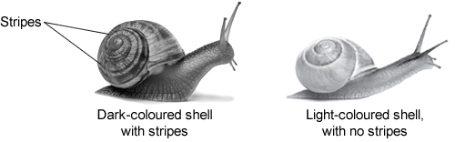

Figure 2 shows results from surveys in woodlands and in grasslands of the percentage of snails with light-coloured shells and the percentage of snails with no stripes. Each point on the graph represents the results of one survey in one habitat.
Figure 2
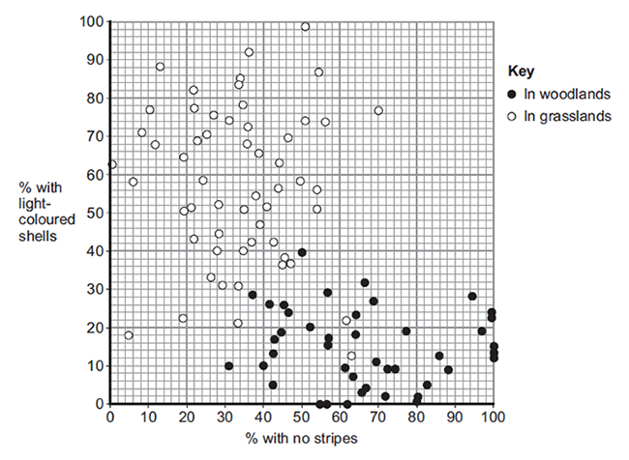
(i) Figure 2 is a scatter graph. Why is a scatter graph used for this data?
__________________________________________________
__________________________________________________
(1)
(ii) Compare the general appearance of snails that live in woodlands with the general appearance of snails that live in grasslands.
__________________________________________________
__________________________________________________
__________________________________________________
(2)
(iii) Suggest a reason for the general appearance of snails that live in woodlands.
__________________________________________________
__________________________________________________
(1)
(Total 7 marks)
Q5. Freshwater streams may have different levels of pollution. The level of pollution affects which species of invertebrate will live in the water. Table 1 shows the biomass of different invertebrate species found in two different streams, X and Y.
Table 1

 | Biomass in g
Invertebrate species | Stream X | Stream Y
Mayfly nymph | 4 | 0
Caddis fly larva | 30 | 0
Freshwater shrimp | 70 | 5
Water louse | 34 | 10
Bloodworm | 10 | 45
Sludge worm | 2 | 90
Total | 150 | 150
(a) The bar chart below shows the biomass of invertebrate species found in Stream X.
(i) Complete the bar chart by drawing the bars for water louse, bloodworm and sludge worm in Stream Y. Use the data in Table 1.
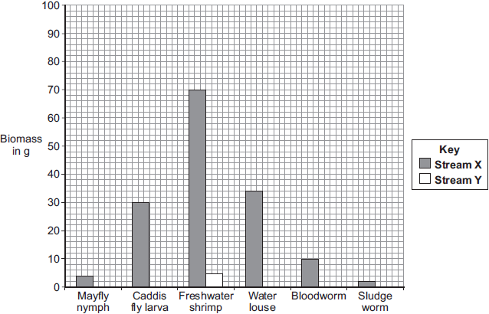
Species present
(2)
(ii) Table 2 shows which invertebrates can live in different levels of water pollution.
Table 2

Pollution level | Invertebrate species likely to be present
Clean water | Mayfly nymph
Low pollution | Caddis fly larva, Freshwater shrimp
Medium pollution | Water louse, Bloodworm
High pollution | Sludge worm
Which stream, X or Y, is more polluted?
Use the information from Table 1 and Table 2 to justify your answer.
__________________________________________________
__________________________________________________
__________________________________________________
__________________________________________________
(2)

(b) There is a sewage works near another stream, Z.
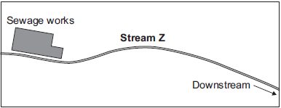
An accident caused sewage to overflow into Stream Z. Two weeks later scientists took samples of water and invertebrates from the stream. They took samples at different distances downstream from where the sewage overflowed. The scientists plotted the results shown in Graphs P and Q.
Graph P: change in water quality downstream of sewage overflow
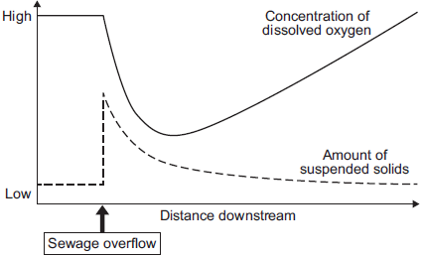
Graph Q: change in invertebrates found downstream of sewage overflow
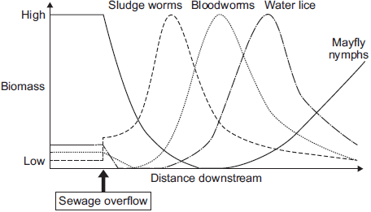
(i) Describe the patterns shown in Graph P.
__________________________________________________
__________________________________________________
__________________________________________________
__________________________________________________
__________________________________________________
(4)
(ii) Describe the relationship between dissolved oxygen and the survival of mayfly nymphs in Stream Z. Suggest a reason for the pattern you have described.
__________________________________________________
__________________________________________________
__________________________________________________
__________________________________________________
(3)
(c) Many microorganisms are present in the sewage overflow. Explain why microorganisms cause the level of oxygen in the water to decrease.
______________________________________________________
______________________________________________________
______________________________________________________
______________________________________________________
(2)
(Total 13 marks)
Q6. In this question you will be assessed on using good English, organising information clearly and using specialist terms where appropriate.
Animals and plants have features (adaptations) that allow them to survive in the conditions in which they normally live. Describe how animals and plants are adapted to survive in dry conditions such as deserts. For each adaptation that you give, describe how the adaptation helps the animal or plant to survive in dry conditions.
To obtain full marks you should refer to both animals and plants.
___________________________________________________________
___________________________________________________________
___________________________________________________________
___________________________________________________________
___________________________________________________________
___________________________________________________________
___________________________________________________________
___________________________________________________________
___________________________________________________________
___________________________________________________________
___________________________________________________________
(Total 6 marks)
Q7. The table shows energy transfers in a large insect and a small mammal. Both animals feed mainly on grass.

Energy transfer | Amount of energy in kJ.
 | Large insect | Small mammal
Eaten as grass | 4.00 | 25.00
Absorbed into body | 1.60 | 12.50
Leaves body as faeces | 2.40 | 12.50
Production of new tissue | 0.64 | 0.25
Transferred by respiration | 0.96 | 12.25
(a) What percentage of the energy in food is transferred into new tissue in the large insect? Show clearly how you work out your answer.
______________________________________________________
______________________________________________________
______________________________________________________
Answer = ______________________________ %
(2)
(b) The proportion of energy in the food transferred into new tissue is much greater in the large insect than in the small mammal. Explain why as fully as you can.
You should include references to the data in your answer.
______________________________________________________
______________________________________________________
______________________________________________________
______________________________________________________
______________________________________________________
(3)
(Total 5 marks)
Q8. Students investigated a food chain in a garden. The students found 650 aphids feeding on one bean plant. Five ladybirds were feeding on the aphids.
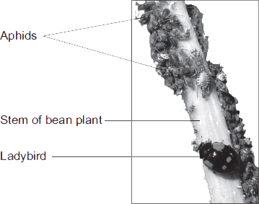

(a) (i) Draw a pyramid of biomass for this food chain. Label the pyramid.

(2)
(ii) The biomass in the five ladybirds is less than the biomass in the bean plant. Give two reasons why.
__________________________________________________
__________________________________________________
__________________________________________________
__________________________________________________
(2)
(b) The carbon in dead bean plants is returned to the atmosphere via the carbon cycle. Describe this part of the carbon cycle.
______________________________________________________
______________________________________________________
______________________________________________________
______________________________________________________
______________________________________________________
______________________________________________________
______________________________________________________
(4)
(Total 8 marks)
Q9. At the seashore, the tide comes in and goes out twice each day. Some students investigated whether two different species of seaweed could live only at certain positions on a rocky shore. Seaweeds are plant-like organisms that make their food by photosynthesis.
Figure 1 shows the two species of seaweed that the students investigated.
Figure 1
Bladder wrack Sea lettuce
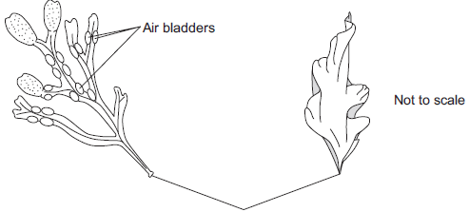
Holdfast
(fixes seaweed to the rock)
(a) The students:
1 placed a 50-metre tape measure on the rocks at right angles to the sea
2 placed a quadrat next to the tape measure
3 recorded whether each species was present or not.
The students repeated steps 2 and 3 every metre down the shore. Figure 2 shows a section of the seashore and the students’ results.
Figure 2
Section of the seashore
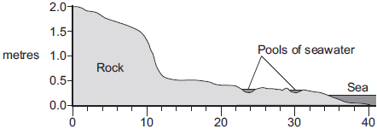
metres
Students’ results
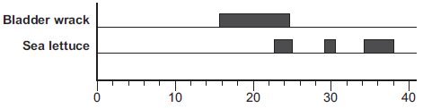
metres
(i) The students placed the quadrat at regular intervals along a transect line rather than placing the quadrat at random positions anywhere on the rocky shore. Explain why.
__________________________________________________
__________________________________________________
__________________________________________________
__________________________________________________
(2)
(ii) How could the students have improved their investigation to ensure that they produced valid data?
__________________________________________________
__________________________________________________
__________________________________________________
__________________________________________________
(2)
(iii) Figure 2 is repeated here to help you answer this question.
Figure 2
Section of the seashore
metres
Students’ results
metres
The students concluded that bladder wrack is better adapted than sea lettuce to survive in dry conditions. What is the evidence for this conclusion? Use information from Figure 2.

__________________________________________________
__________________________________________________
__________________________________________________
__________________________________________________
(2)
(b The bladder wrack has many air bladders.
The air bladders help the bladder wrack to float upwards when the sea covers it. Suggest how this helps the bladder wrack to survive.
______________________________________________________
______________________________________________________
______________________________________________________
______________________________________________________
(2)
(Total 8 marks)
Q10. A grassy field on a farm measured 120 metres by 80 metres. A student wanted to estimate the number of buttercup plants growing in the field. The student found an area where buttercup plants were growing and placed a 1 m × 1 m quadrat in one position in that area.
Figure 1 shows the buttercup plants in the quadrat.
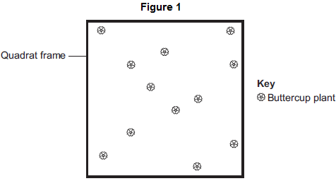
The student said, 'This result shows that there are 115 200 buttercup plants in the field.'
(a) (i) How did the student calculate that there were 115 200 buttercup plants in the field?
__________________________________________________
__________________________________________________
__________________________________________________
__________________________________________________
(2)
(ii) The student’s estimate of the number of buttercup plants in the field is probably not accurate. This is because the buttercup plants are not distributed evenly. How would you improve the student’s method to give a more accurate estimate?
__________________________________________________
__________________________________________________
__________________________________________________
__________________________________________________
(2)
(b) Sunlight is one environmental factor that might affect the distribution of the buttercup plants.
(i) Give three other environmental factors that might affect the distribution of the buttercup plants.
1. ____________________________________________________________
2. ____________________________________________________________
3. ____________________________________________________________
(3)
(ii) Explain how the amount of sunlight could affect the distribution of the buttercup plants.
(3)
(c) Figure 2 is a map showing the position of the farm and a river which flows through it.
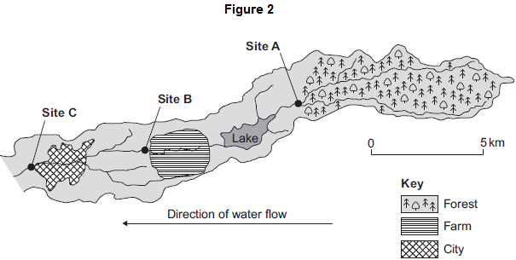
Every year, the farmer puts fertiliser containing mineral ions on some of his fields.When there is a lot of rain, some of the fertiliser is washed into the river.
(i) When fertiliser goes into the river, the concentration of oxygen dissolved in the water decreases.
Explain why the concentration of oxygen decreases.
_____________________________________________________________
_____________________________________________________________
_____________________________________________________________
_____________________________________________________________
_____________________________________________________________
_____________________________________________________________
_____________________________________________________________
_____________________________________________________________
(5)
(ii) There is a city 4 km downstream from the farm.Apart from fertiliser, give one other form of pollution that might go into the river as it flows through the city.
_____________________________________________________________
(1)
(d) Three sites, A, B and C, are shown in Figure 2.
Scientists took many samples of river water from these sites. The scientists found larvae of three types of insect in the water: mayfly, stonefly and caddisfly. For each type of insect the scientists found several different species. The scientists counted the number of different species of the larvae of each of the three types of insect.
Figure 3 shows the scientists’ results.
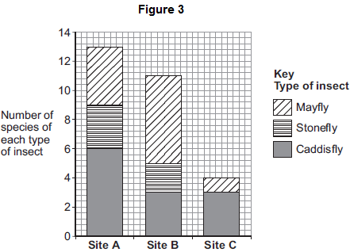
(i) How many more species of mayfly were there at Site B than at Site A?
____________________
(1)
(ii) Suggest what caused this increase in the number of species of mayfly.
_____________________________________________________________
_____________________________________________________________
(1)
(iii) The scientists stated that the number of species of stonefly was the best indicator of the amount of oxygen dissolved in the water. Use information from Figure 3 to suggest why.
(1)
(Total 19 marks)
Q11. A gardener investigates if turning over the waste in a compost heap makes the waste decay more quickly.
The gardener:
• makes two separate heaps of garden waste, heap A and heap B
• turns over the material in heap A every 2 weeks
• does not turn over the material in heap B
• estimates the amount of decay in the two heaps after 6 months.
The diagram shows the two heaps of garden waste at the beginning of the investigation.
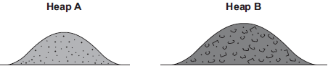
(a) Suggest two factors, other than time, the gardener should control to make the investigation fair.
1. _________________________________________________________________
_________________________________________________________________
2. _________________________________________________________________
_________________________________________________________________
(2)
(b) Name one type of living thing that causes decay.
_________________________________________________________________
(1)
(c) The gardener’s results are shown in the table.

Compost heap | Estimated amount of decay
A | A lot
B | Very little
(i) Why does turning over the material in heap A make the material decay more quickly?
_____________________________________________________________
_____________________________________________________________
(1)
(ii) The gardener puts decayed material around his plants to help them grow.
Suggest why the plants in a woodland grow well each year without material from compost heaps being added.
_____________________________________________________________
_____________________________________________________________
_____________________________________________________________
_____________________________________________________________
(2)
(Total 6 marks)
Q12. Some students set up biogas generators to find out which type of animal manure produced the most biogas. The diagram shows the apparatus they used.
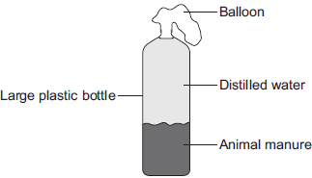
The students:
Step 1: Put some cow manure into the plastic bottle
Step 2: Filled the bottle with distilled water
Step 3: Attached a balloon over the top of the bottle
Step 4: Put the bottle in a warm room for 10 days
Step 5: Measured the diameter of the balloon on day 10
Step 6: Repeated steps 1 to 5 using each type of animal manure.
The students’ results are shown in the table.

Type of animal manure | Diameter of balloon on day 10 in cm
Cow | 29
Horse | 26
Sheep | 34
Pig | 32
(a) What is the main gas found in biogas?
_________________________________________________________________
(1)
(b) The students concluded that sheep manure is the best type of manure to use in a biogas generator. A teacher told the students that the design of their investigation meant that their conclusion might not be correct. Suggest two reasons why.
1. _________________________________________________________________
_________________________________________________________________
2. _________________________________________________________________
_________________________________________________________________
(2)
(c) Another student suggested that adding potato to the manure would increase the amount of biogas produced.
Why would adding potato increase the amount of biogas produced?
Tick () one box.

The potato contains a lot of carbohydrate.
The potato contains a lot of protein.
The potato contains a lot of water.
(1)
(Total 4 marks)
Q13. This question is about carbon.
The graph shows the mass of carbon added to and removed from the atmosphere each year.
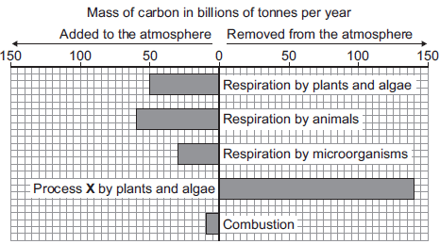
(a) Name process X.
_________________________________________________________________
(1)
(b) (i) Calculate the mass of carbon added to the atmosphere by respiration per year.
Answer = ____________________ billion tonnes
(1)
(ii) Some scientists are concerned that the mass of carbon in the atmosphere is changing.
How does the data in the graph support this idea?
_____________________________________________________________
_____________________________________________________________
(1)
(Total 3 marks)

Mark schemes
Q1.
(a) pupils dilated (at B) allow converse for A
1
in dim light / low light levels
1
because circular muscles (in iris) relax
1
(and) radial muscles contract
1
(b) figure 2 shows myopia where light does not focus on the retina
allow refraction
1
in figure 3 the lens bends the light so that light focuses on the retina
1
[6]
Q2. (a) any two from:
• drop the ruler from the same height each time
• let the ruler drop without using any force
• same type / weight of ruler
• thumb should be same distance from the ruler each time at the start
• use the same hand to catch the ruler each time
• carry out the experiment with the lower arm resting in the same way on the table
allow description of holding bottom edge of ruler opposite the catcher’s thumb
2
(b) 117
1
(c) 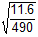
1
0.1539 allow 01539 with no working shown for 2 marks
1
0.154 allow 0.154 with no working shown for 3 marks
1
allow ecf as appropriate
(d) no indication beforehand when the colour will change
or
you might be able to tell when the person is about to drop the ruler
1
measurement of time is more precise (than reading from a ruler)
or
resolution (of computer timer) is higher
1
(e) cerebral cortex
allow cerebrum
1
ignore identified lobes
(f) cerebellum
1
[10]
Q3. (a) any two from:
• drop the ruler from the same height
• use the same / dominant hand each time
• thumb same distance from ruler at the start
• use same type / weight of ruler
• drop the ruler without any force each time
• keep arm resting on the edge of the table
2
(b) 8
allow 8.0
1
(c) 2 (in test number 2)
1
(d) 12
1
(e) (12 + 13 + 13 + 9 + 8 / 5 =) 11
1
(f) 0.15 − 0.12 (s)
1
0.03 (s)
allow 0.03 (s) with no working shown for 2 marks
1
(g) carry out more repeats
1
(h) caffeine speeds up reflex actions
or
reduces reaction time
1
[10]
Q4. (a) if too high insulin released from pancreas
1
so glucose is moved into cells allow glucose is stored
1
if too low, glucagon is released (from pancreas)
1
causes glycogen to be converted to glucose and released into the blood
1
(b) type 1 not enough / no insulin produced
1
whereas type 2 cells do not respond to insulin
1
type 1 is treated with injections of insulin
1
whereas type 2 is treated with diet and exercise
or
loss of weight
or
drugs
1
(c) (3.45 × 10⁶) + (5.49 × 10⁵) = 3.999 × 10⁶
or
3 450 000 + 549 000 = 3 999 000
allow 3.999 × 10⁶ or 3 999 000 with no working shown for 1 mark
1
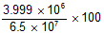
or
= 6.15
allow 6.15 with no working shown for 2 marks
allow for 1 mark for a calculation using either:
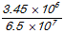
or
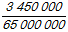
or
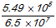
or
1
6.2 allow 6.2 with no working shown for 3 marks
1
allow ecf from second step correctly rounded for 1 mark
(d) could be other reasons for glucose in urine
or
blood test gives current / immediate result, urine levels might be several hours old
or
not always glucose in urine
1
(e) results not affected by glucose from food
or
8 hours is sufficient time for insulin to have acted on any glucose from food eaten
or
so that there is a low starting point to show the effect
1
(f) (patient A)
no mark for identifying A
glucose level much higher (than B)
1
and remains high / does not fall
1
[15]
Q5.
(a) A sperm
1
B egg
1
C fertilised egg
1
D embryo
1
(b) insert into mother
ignore fertilise / check fertilisation / check viability
1
womb / uterus
1
(c) (i) one quarter
1
(ii) no / little chance of success over 42
1
reference to table of only two women in the age bracket 40-42 years became pregnant
the statement ‘only 2 out of 53 40-42 year old women became pregnant / had babies’ gains 2 marks
1
(iii) so fewer twins / multiple births
or
multiple births more dangerous
1
[10]
Q6.
Marks awarded for this answer will be determined by the Quality of Communication (QC) as well as the standard of the scientific response. Examiners should also apply a ‘best-fit’ approach to the marking.
0 marks
No relevant content.
Level 1 (1 – 2 marks)
There is a description of thermoregulation or at least one correct mechanism (skin, sweat glands or muscles) but roles may be confused.
Level 2 (3 – 4 marks)
There is a description of thermoregulation or some correct mechanisms (sweating, shivering, blood flow in the skin).
Level 3 (5 – 6 marks)
There is a clear description of thermoregulation by TC or skin and some correct control mechanisms.
examples of biology points made in the response:
full marks may be awarded for detailed description of what happens if the core temperature is either too high or too low
• temperature receptors in TC
• the TC detects (core) body / blood temperature
• temperature receptors in the skin send impulses to the TC, giving information about skin temperature
• if the core body temperature is too high: blood vessels / arterioles supplying the skin capillaries dilate / vasodilation
do not accept refs to veins instead of arterioles or answers that imply blood vessels have moved up / down through the skin.
• so that more blood flows (through the skin) and more heat is lost
• sweat glands release more sweat to cool the body
• by evaporation
• if the core body temperature is too low: blood vessels supplying the skin capillaries constrict
• to reduce the flow of blood (through the skin) and less heat is lost
allow idea of blood diverted to vital organs in extreme cold
• muscles may shiver to release (heat) energy
• from respiration, some of which is lost as heat
[6]
Q7.
(a) sensory neurone
1
(b) (i) synapse
1
(ii) a chemical
1
(c) (What happens to the muscle) mark both parts of the question together
any one from:
• contraction / contracts ignore relaxation / relaxes / tenses
1
• gets shorter
(How this helps the body) idea of protection for body (from damage / pain)
eg moves finger / arm away (from pin / stimulus / source of pain)
1
[5]
Q8. (a) motor
allow efferent / postsynaptic
allow another relay (neurone)
1
(b) release of chemical (from relay neurone)
allow ecf for ‘motor’ neurone from (a)
allow release of neurotransmitter / named example
1
chemical crosses gap / junction / synapse
allow diffuses across
allow chemical moves to X
1
chemical attaches to X / motor / next neurone (causing impulse)
1
(c) (curare) decrease / no contraction
accept (muscle) relaxes
1
(strychnine) increase / more contraction
if no other mark awarded allow 1 mark for (curare) decrease / no response and (strychnine) increase / more response
1
[6]

Q9. (a) receptors detect / sense stimuli / change in surroundings or convert stimulus into an impulse ignore send impulses to brain / spinal cord
1
example of a receptor
allow any appropriate organ or part of an organ, eg eye / retina or named type of receptor eg light receptor
1
effectors allow / make response or convert an impulse to an action
ignore receive impulses from brain / spinal cord
1
(effector) muscle / gland allow an example ignore eg arm / leg
1
(b) (i) junction allow idea of a (small) gap / space
do not allow if implication is that the neurones move
1
between neuron(e)s allow named types of neurones
1
(ii) chemical allow answers in terms of specific types of neurone
allow neurotransmitter / named neurotransmitter released
1
any one from:
• (chemical released) from one neurone
ignore produced
• (chemical) passes (across synapse) to next neurone to stimulate / cause (electrical) impulse
allow diffuses for passes (across)
1
(c) (i) skin ignore hand / leg
1
(ii) 1.6 (cm per millisecond) allow 2 if evidence of rounding up of 1.6
1
(iii) any two from: ignore length of neurones
• synapses slow down transmission / impulse
allow idea of movement of chemical being slower than electrical impulse
• fewer synapses (via brain)
allow one synapse compared to two or only one synapse
• (therefore) fewer delays
allow impulse travels more slowly in relay neurones
2
[12]
Q10. (a) Too much thyroxine is released into the blood
1
which raises BMR
1
causing increase in formation of glycogen / lipids / proteins
or
increase in rate of respiration
or
increase in breakdown of excess proteins
1
(b) FSH causes eggs to mature and stimulate ovaries to produce oestrogen
1
LH stimulates the egg to be released
1
(c) (missing a dose causes a) dip / drop in progesterone levels
1
(therefore) FSH is not inhibited anymore
1
(therefore) LH is not inhibited anymore
1
(and consequently) an egg is matured and released
allow (and consequently) an egg is available to be fertilised
1
[9]
Q11.
(a) (i) stimulus
1
(ii) cytoplasm
1
(b) (i) ear(s) in this order only
1
eye(s) accept retina
1
Skin ignore extra detail
1
(ii) A muscle
1
[6]
Q12. (a) (i) chemical
1
(ii) pituitary gland
1
(b) 8 allow 9 or 10
1
(c) (i) any four from:
• progesterone starts being produced at 4 weeks / no progesterone before 4 weeks
• and then / from 4 weeks increases
• oestrogen at constant / low level (from 0) to 20 weeks
• and then / from 20 weeks increases
• from 20 − 36 weeks level of O rises more steeply than that of P
or
• P is always higher than 0 from 6 to 36 weeks
if no other marks awarded, allow progesterone and oestrogen both increase / rise for 1 mark.
4
(ii) oxytocin
1
level of oxytocin increases just before birth
1
[9]
Q13. (a) (i) follicle stimulating hormone / FSH
1
(ii) oestrogen
1
(b) (i) any one from:
• to help them have a baby / get pregnant
ignore to make them fertile
• to stimulate egg production / release / maturation
• own levels of FSH / LH / hormone (too) low
allow to increase hormone / FSH / LH levels
do not allow to increase oestrogen levels
1
(ii) through the bloodstream
1
(c) oestrogen
1
progesterone
1
[6]
Q14.
(a) ovary
1
(b) 46
1
(c) (i) does not fit the pattern
or
it is higher than the 3rd value / it should be lower than the 3rd value / it should be between the 3rd and 5th values
do not allow use of incorrect figures
1
(ii) As age increases % of women (having a baby) decreases
1
(d) (i) 33
allow 1 mark for
if no answer / wrong answer
2
(ii) low success rate
1
more likely to have a baby with health problems / abnormalities / a faulty chromosome
1
[8]
Mark schemes
Q1.
(a) phosphate
allow PO₄³⁻
1
do not allow P
(b) A / adenine and T / thymine
and
C / cytosine and G / guanine
do not allow U / uracil
1
(c) (mutation) changes from C to T DNA code
or
there is a change in the three bases / triplet from CAG to TAG
1
(mutation) changes the amino acid
1
(this could) change the protein
1
(so it) forms a different shape / changed active site
accept different tertiary structure
1
(therefore) the enzyme no longer fits the substrate / carbohydrate
1
(d) mother / woman’s gametes correct: A a
1
father / man’s gametes correct: a a
1
correct derivation of offspring
ecf
1
identification of child with syndrome H or genotype aa
1
0.5
ecf
allow 50% / 1 / 2 / 1 in 2 / 1:1
1
do not accept 1:2
[12]
Q2.
(a) (i) man has (inherited) polydactyly (PD) allele (from mother)
1
man has (inherited) other / normal / recessive allele from father
1
because father does not have PD allele or if father had it father would have had PD or father only has normal allele or father is homozygous recessive
1
allow gene for allele
(ii) 0.5 / ½ / 1 in 2 / 1:1 / 50%
do not allow 1:2 or 50/50
allow 50:50
1
(b) parental phenotypes: both brown
1
parental genotypes: both Bb
1
gametes: B b and B b
1
allow only on gametes answer line
allow ecf from genotypes
offspring genotypes: BB (2)Bb bb
allow ecf from gametes
1
offspring phenotypes correctly assigned to genotypes:
BB & Bb = brown bb = red
do not penalise confusion of ‘phenotypes’ & ‘genotypes’ here
1
[9]
Q3.
(a) When the dominant allele is not present.
1
(b) (i) Bb
1
(ii) 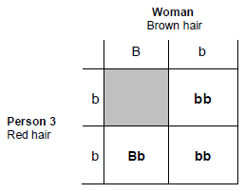
3 correct = 2 marks
2 correct = 1 mark
1 or 0 correct = 0 marks
allow bB for Bb
2
(iii) 1 in 2
allow ecf from part ii
1
[5]
Q4.
(a)
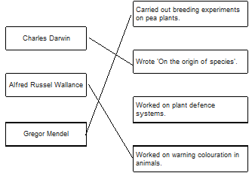
3
(b) a gene allow allele
1
(c) 4
1
(d) correct derivation of children’s genotypes
1
identification of children with cystic fibrosis (dd)
1
0.25 allow ecf
allow ¼ / 25% / 1 in 4 / 1:3
1
do not accept 1:4
(e) heterozygous
1
[9]
Q5. (a) (i) gametes apply list principle
1
(ii) chromosomes apply list principle
1
(b) (i) The allele is recessive no mark if more than one box is ticked
1
(ii) two apply list principle
1
(c) (i) A apply list principle
1
(ii) B apply list principle
1
[6]
Q6. (a) A
1
(b)
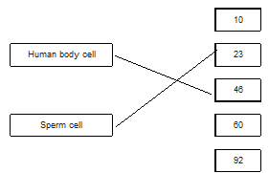
2
(c) one x circled under mother
accept if clearly indicated choice even if not circled
1
(d) XY allow YX
1
(e) 50 (%)
1
[6]
Q7.
(a) both parents Aa
accept other upper and lower case letter without key or symbols with a key
allow as gametes shown in Punnett square
1
aa in offspring correctly derived from parents
or
aa correctly derived from the parents given
ignore other offspring / gametes
for this mark parents do not have to be correct
1
offspring aa identified as having cystic fibrosis
may be the only offspring shown or circled / highlighted / described
1
(b) (i) any one from:
accept converse if clear, eg if you (only) took one it might have cystic fibrosis / might not be fertilised
• (more) sure / greater chance of healthy / non-cystic fibrosis egg / embryo / child
accept some may have the allele
reference to ‘suitable / good embryo’ is insufficient
• greater chance of fertilisation
1
(ii) advantages
to gain 3 marks both advantage(s) and disadvantage(s) must be given
max 3
any two from:
ignore references to abortion unless qualified by later screening
• greater / certain chance of having child / embryo without cystic fibrosis / healthy
• child with cystic fibrosis difficult / expensive to bring up
• cystic fibrosis (gene / allele) not passed on to future generations
disadvantages
any two from:
• operation dangers / named eg infection ignore risk unqualified
• ethical or religious issues linked with killing embryos
accept wrong / cruel to embryos accept right to life argument
ignore embryos are destroyed
• (high) cost of procedure
• possible damage to embryo (during testing for cystic fibrosis / operation)
plus
conclusion
a statement that implies a qualified value judgement
eg it is right because the child will (probably) not have cystic fibrosis even though it is expensive
or
eg it is wrong because embryos are killed despite a greater chance of having a healthy baby
note: the conclusion mark cannot be given unless a reasonable attempt to give both an advantage and a disadvantage is made
do not award the mark if the conclusion only states that advantages outweigh the disadvantages
1
(c) any three from:
• osmosis / diffusion
do not accept movement of ions / solution by osmosis / diffusion
• more concentrated solution outside cell / in mucus
assume concentration is concentration of solute unless answer indicates otherwise or accept correct description of ‘water concentration’
• water moves from dilute to more concentrated solution
allow correct references to movement of water in relation to concentration gradient
• partially permeable membrane (of cell)
allow semi / selectively permeable
3
[11]
Q8.
(a) DNA
1
(b) X and Y
1
(c) (i) 46 chromosomes
1
(ii) half the number
1
(d) meiosis
1
[5]
Q9. (a) (i) in the chromosome(s) ignore genes / alleles
1
in the nucleus allow nuclei allow mitochondria
1
(ii) the DNA / chromosomes / genes are replicated / copied / multiplied / doubled / duplicated
allow DNA is cloned ignore same DNA / chromosomes / genes if unqualified
1
(b) (i) 1 / one
1
(ii) 2 / two
1
(c) B
1
[6]
Q10.
(a) (i) nucleus correct spelling only accept mitochondrion
ignore genes / genetic material / chromosomes
1
(ii) base(s)
Accept all four correct names of bases
ignore nucleotides and refs to organic / N-containing
1
(iii) 4
1
(iv) codes for sequence / order of amino acids
ignore references to characteristics
1
codes for a (specific) protein / enzyme
or
the sequence / order of three bases / compounds / letters
codes for a specific amino acid
or
the sequence / order of 3 bases / compounds / letters
codes for the order / sequence of amino acids
1
(b) (i) DNA
1
circular / a ring or a vector / described
1
(ii) kills any cells not having kan^{r} gene / so only cells with kan^{r} gene survive
1
hence surviving cells will also contain Bt gene / plasmid
1
(iii) cells divide by mitosis ignore ref to asexual reproduction
correct spelling only
1
genetic information is copied / each cell receives a copy of (all) the gene(s) / all cells produced are genetically identical / form a clone
1
(iv) any two from:
• gene may be passed to pathogenic bacteria
• cannot then kill these pathogens with kanamycin
or
cannot treat disease with kanamycin
• may need to develop new antibiotics
• gene may get into other organisms
• outcome unpredictable
2
[13]
Q11. (a) (i) 3.15 : 1 accept 3.147:1 or 3.1 : 1 or 3 : 1
do not accept 3.14 : 1 Ignore 705:224
1
(ii) any two from:
• fertilisation is random or ref. to chance combinations (of alleles / genes / chromosomes)
• more likely to get theoretical ratios or see (correct) pattern or get valid results if large number allow ref. to more representative / reliable
do not allow more accurate or precise ignore fair / repeatable
• anomalies have limited effect / anomalies can be identified
accept example of an anomaly
2
(b) (i) in sequence:
Homozygous
Homozygous
Heterozygous
All 3 correct = 2 marks 2 correct = 1 mark 1 or 0 correct = 0 marks
2
(ii) genetic diagram including:
Parental genotypes: Nn and Nn
allow other characters / symbols only if clearly defined
1
or
Gametes: N and n + N and n derivation of offspring genotypes: NN Nn Nn nn
allow genotypes correctly derived from candidate’s P gametes
1
identification: NN and Nn as purple and nn as white
allow correct identification of candidate’s offspring genotypes but only if some F₂ are purple and some are white
1
(c) any two from:
• did not know about chromosomes / genes / DNA
or did not know chromosomes occurred in pairs
ignore genetics
• had pre-conceived theories
eg blending of inherited characters
ignore religious ideas unless qualified
• Mendel’s (mathematical) approach was novel concept
allow his work was not understood or no other scientist had similar ideas
• Mendel was not part of academic establishment
allow he was not considered to be a scientist / not well known / he was only a monk
• work published in obscure journal / work lost for many years
• peas gave unusual results cf other species
allow he only worked on pea plants
• Mendel’s results were not corroborated until later / 1900
2
[10]

Mark schemes
Q1.
(a) snail
or
shrew
additional incorrect answer negates correct answer
1
(b) shrew
additional incorrect answer negates correct answer
1
(c) fewer shrews to eat them
1
(d) population
1
(e) C
1
(f) (11 000 × 0.1 =)
1 100 (kJ)
1
(g) the snails do not eat the roots of the lettuces
1
(h) any one from:
• light (intensity)
• temperature
• moisture (levels)
• soil pH
• mineral / ion content (of soil)
• wind intensity / speed
ignore wind direction
• carbon dioxide (levels)
• oxygen (levels)
1
[8]
Q2.
(a) measure the length / area of the field
1
(b) use (a) random number(s) (generator)
or
use coordinates method explained
1
(c) compare their results with another student’s results
1
place more quadrats
1
(d) 0.25 × 5 = 1.25
1
500 / 1.25 = 400
1
(40 × 400 =) 16 000
allow 16 000 with no working shown for 3 marks
1
(e) 11
1
(f) (quadrat) 5
both quadrat number and correct reason must be given for 1 mark
1
very few or only 2 growing (here)
[9]
Q3.
(a) wear a face mask
allow wear gloves
1
(b) Level 2 (3–4 marks):
A detailed and coherent plan covering all the major steps. It sets out the steps needed in
a logical manner that could be followed by another person to produce an outcome which
will address the hypothesis.
Level 1 (1–2 marks):
Simple statements relating to steps are made but they may not be in a logical order. The plan may not allow another person to produce an outcome which will address the hypothesis.
0 marks:
No relevant content.
Indicative content
Plan:
• cut a specified number of pieces of bread to the same size
• place mould spores on the bread
• the number of mould spores needs to be the same quantity of mould spores on
each piece of bread
• place bread in different sealable plastic bags
• place in different temperatures (minimum of three) eg fridge, room, incubator
• leave each for the same amount of time eg four days
• measure the percentage cover of mould on each piece of bread
• repeat experiment
additional examiner guidance:
• good level 2 answer will describe how the growth of mould can be measured and
will give a range of different temperatures to be used
• allow equivalent levels of credit for alternative methodologies that would clearly produce a measurable outcome in terms of mould growth at various temperatures
4
(c) any one from:
• type of mould
• amount of mould (put on each piece of bread)
• amount of air in the plastic bags
• size of the pieces of bread
• type of bread
• amount of moisture / water added
1
(d) (56 − 4 = 52) / 5
1
10.4
allow 10.4 with no working shown for 2 marks
1
ecf for incorrectly read figures for 1 mark
(e) (decomposition occurs at a faster rate when the temperature is higher
or
amount of decomposition is higher when temperature is higher
1
[9]
Q4.
(a) (i) any two from:
• not all eaten allow eaten by other animals
• used for respiration ignore used / lost in heat / movement
• lost as CO₂ / water / urea
• lost as faeces or not all digested
if neither mark awarded allow 1 mark for lost as waste
ignore references to energy losses do not allow for growth / repair / reproduction
2
(ii) any one from:
• thrushes eat other things
• thrush numbers likely to vary (considerably)
allow it is only an estimate (of population size) or only counted thrushes for 5 hours
• thrushes were not present all the time
• thrushes feed on a much bigger area
1
(b) (i) any one from:
• there are two dependent variables
• there is no independent variable
• to show the association / correlation / pattern (between the two variables)
1
(ii) (snails in woodlands)
more have dark(er) colour(ed shells) or fewer have light-coloured shells
allow converse for grassland, if clear
1
(shells have) no / fewer stripes or have no stripes
allow converse for grassland, if clear
1
(iii) less likely to be seen (by predators / birds / thrushes)
allow camouflaged (from predators / birds / thrushes)
allow light coloured shells with stripes would be more visible (to predators / birds / thrushes in woodland (than grassland)).
1
[7]
Q5.
(a) (i) correct bar heights
three correct 2 marks
two correct 1 mark
one or none correct 0 marks
ignore width
2
(ii) (Stream Y)
has many sludge worms / bloodworms
or
has no mayflies / caddis or few shrimp
allow 1 mark if invertebrate not named but correct association given
1
which indicate medium or high pollution
1
(b) (i) suspended solids increase (as a result of sewage overflow)
1
then decrease downstream / return to original levels
1
oxygen levels decrease (after sewage overflow)
1
and then rise again
1
(ii) any three from:
• mayflies decrease (to zero) near overflow
accept ‘have died outߣ
• because oxygen is low or mayflies have high oxygen demand
• mayflies repopulate / increase as oxygen increases again
• can’t be sure if dissolved oxygen or suspended solids is the cause
3
(c) they respire / respiration
aerobic respiration gains 2 marks
1
this requires / uses up the oxygen
1
[13]
Q6.
Marks awarded for this answer will be determined by the Quality of Written Communication (QWC) as well as the standard of the scientific response. Examiners should apply a ‘best-fit’ approach to the marking.
0 marks
No relevant content.
Level 1 (1 – 2 marks)
At least one way in which animals and / or plants are adapted to survive.
Level 2 (3 – 4 marks)
A description of ways in which animals and / or plants are adapted and an attempt to link at least one adaptation to how it increases the chance of survival.
Level 3 (5 – 6 marks)
A description of ways in which animals and plants are adapted and a description of how at least one adaptation increases the chance of survival.
examples of biology points made in the response:
(animals)
(A) change / decrease in surface area / example
(decrease in surface area which) reduces area from which sweat / water may be lost
(A) hump with fat / fat stores
(fat in hump) to convert to water (via respiration)
(A) long eyelashes
(long eyelashes) to keep (wind-blown) dust out of eyes
(A) nocturnal / ‘keep out of the sun’
reduce sweat loss (in heat of the day)
extra information
allow adaptations of specific animals to living in specified dry conditions, eg a desert
(A) change / increase in surface area / example
(increase in surface area which) increases area heat may be lost from (by radiation)
(A) changes to thickness of insulating coat
(thicker coat on upper surface) increases insulation from sun’s heat
(A) thin (layer) / reduced amount of body fat
(reduced amount of body fat which) reduces insulating layer
(A) wide feet
(wide feet) to reduce pressure / spread weight / prevent sinking
(plants)
(A) decrease in surface area
(A) leaves are spikes
(reduced area / leaves are spikes) reduces water loss / transpiration / evaporation
(A) long / wide spread / extensive roots
(long / wide spread /extensive roots) to absorb (more) water
(A) fleshy / thick stem
(fleshy / thick stem) to store water
extra information
allow adaptations of specific plants to living in specified dry conditions, eg a desert
(A) thick wax
(thick wax) to reduce evaporation / water loss / transpiration
(A) few(er) stomata
(few stomata) to reduce evaporation / water loss / transpiration
[6]
Q7.
﻿
(a) 16
accept correct answer for 2 marks, irrespective of working
if no answer or answer incorrect accept 0.64 x 100 / 4 (.0) or 0.16 for 1 mark
2
(b) insect cold-blooded / not warm blooded or does not control body temperature
accept mammal warm-blooded / constant (high) body temperature / controls body temperature
1
reference to insect 0.96 (kJ) and mammal 12.25 (kJ) transferred by respiration
or relevant calculation of this transfer
ignore references to other data
1
(less respiration) so more energy / biomass / food available (for growth of insect)
(more respiration) so less energy / biomass / food available (for growth of mammal)
1
[5]
Q8.
(a) (i) triangular pyramid with 3 layers
may be as blocks or as triangle
ignore food chains and arrows
1
layers appropriately labelled:
bean / plant
aphid,
ladybird
labelled in food chain order must not contradict correct pyramid
allow correctly labelled inverted pyramid for 2 marks
1
(ii) any two from:
(for aphid / ladybird)
ignore energy
• not all digested / faeces
• loss in urine
• loss of CO₂
ignore loss of CO_{2 from bean plant}
• not all eaten
if none of first 3 points given then allow waste (materials) / excretion for 1 mark
2
(b) microorganisms / microbes / bacteria / fungi / decomposers / detritivores /named
do not accept germs allow mould
ignore aphids
1
decay / breakdown / digest / decompose / rot (bean plant)
ignore eat
1
respiration (of microorganisms etc / aphids)
allow burning / combustion
1
carbon dioxide released (from respiration of microorganisms etc / aphids)
allow carbon dioxide released / produced (from burning / combustion)
ignore other parts of the carbon cycle
ignore formation of fossil fuels
1
[8]
Q9.
(a) (i) to get data re position of seaweed / of organism
1
in relation to distance from sea / distance down shore / how long each seaweed was exposed
1
(ii) repeat several times
minimum = 2 repeats
1
elsewhere along the shore
1
(iii) bladder wrack is further up the shore (than the sea lettuce) / exposed for longer
ignore found in dry areas / on bare rock
1
sea lettuce (only) in rock pools / in the sea / (only) in water
1
(b) gets more light / closer to light allow better access to CO₂
1
(so) more photosynthesis allow 1 mark for light for photosynthesis
allow 1 mark for CO₂ for photosynthesis
ignore reference to oxygen for respiration
‘more’ only needed once for 2 marks
1
[8]
Q10.
(a) (i) counts / 12
1
× 120 × 80 / × 9600
or
× area of field
1
(ii) (more) quadrats / repeats
1
placed randomly
ignore method of achieving randomness
1
(b) (i) any three from:
• temperature / warmth / heat
• water / rain
• minerals / ions / salts (in soil)
allow nutrients / fertiliser / soil fertility
ignore food
• pH (of soil)
• trampling
• herbivores
ignore predators
• competition (with other species)
• pollution qualified e.g. SO₂ / herbicide
• wind (related to seed dispersal).
ignore space / oxygen / CO₂ / soil unqualified
3
(ii) light needed for photosynthesis
1
for making food / sugar / etc.
1
effect on buttercup distribution eg more plants in sunny areas / fewer plants in shady areas
1
(c) (i) fertiliser / ions / salts cause growth of algae / plants
1
(algae / plants) block light
1
(low light) causes algae / plants to die
1
microorganisms / bacteria feed on / break down / cause decay of organic matter / of dead plants
do not allow germs / viruses
1
(aerobic) respiration (by microbes) uses O₂
do not allow anaerobic
1
(ii) sewage / toxic chemicals / correct named example eg metals / bleach / disinfectant / detergent etc
allow suitable named examples eg metals such as Pb / Zn / Cr / oil / SO₂ / acid rain / pesticides / litter
ignore chemicals unqualified
ignore waste unqualified
ignore human waste / domestic waste / industrial waste unqualified
1
(d) (i) 2
1
(ii) more food
allow other sensible suggestion eg more species colonise from tributary streams after forest
1
(iii) number of stonefly species decreases (from A to B / B to C / A to C) as more pollution enters river / less oxygen
allow fewer species in more polluted water
ignore none are found at site C
1
[19]
Q11.
(a) any two from:
• amount of waste on each heap
allow size of heap
• (type of) materials on each heap
if neither marking points one or two awarded, allow 1 mark for same waste
• put heaps in same (environmental) conditions.
e.g. keep at same (outside) temperature
allow put in same place
2
(b) microorganisms / microbes / bacteria / fungi / decomposers
ignore detritivores / examples (such as worms, maggots, insects)
ignore pathogens / germs
do not allow viruses
1
(c) (i) oxygen / air added (when turning over)
allow idea that decay will be aerobic
allow bacteria / microorganisms need oxygen / air
allow (microorganisms) respire faster
1
(ii) any two from:
• dead leaves / fruit / plants (fall off / onto the ground)
• (fallen dead leaves / fruit / plants) decay
• minerals / ions / nutrients are recycled / released.
ignore references to carbon dioxide
allow animal waste or dead animals
2
[6]
Q12. (a) methane / CH₄
allow CH₄
do not allow CH⁴ or ch4 or CH4
1
(b) any two from:
• didn’t carry out repeats
• only tested four types of manure
• don’t know the mass of manure was the same each time
• inaccuracies in measuring (diameter of) balloon
• bottles might have been different sizes
• temperature of the room may have been different.
2
(c) The potato contains a lot of carbohydrate
1
[4]
Q13.
(a) photosynthesis
1
(b) (i) 140
1
(ii) (10 billion tonnes) more added (to atmosphere) than removed
allow ecf from part (b)(i)
1
[3]

