Questions
Q1.
Which of these carbon structures is represented by the diagram below?
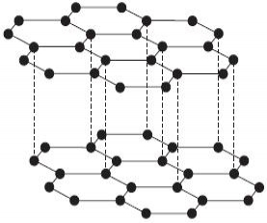
A Graphite
B Diamond
C A fullerene
D A carbon nanotube
(Total for question = 1 mark)

Q2.
This question is about bond angles.
A 90°
B 104°
C 107°
D 109.5°
Select, from A to D above, the most likely value for the bond angle of
(a) HCH in methane, CH₄.
(1)
A
B
C
D
(b) FSF in sulfur hexafluoride, SF₆.
(1)
A
B
C
D
(c) FOF in oxygen difluoride, OF₂.
(1)
A
B
C
D
(Total for question = 3 marks)

Q3.
The oxygen atom in a molecule of water has two bonding pairs and two lone pairs of electrons. Based on the electron-pair repulsion theory, the H–O–H bond angle is most likely to be
A 180°
B 109.5°
C 107°
D 104.5°
(Total for question = 1 mark)

Q4.
What is the FBF bond angle in boron trifluoride, BF₃?
A 180°
B 120°
C 109.5°
D 90°
(Total for Question = 1 mark)

Q5.
Which of these bond angles is the smallest?
A HNH in NH₃
B HCH in CH₄
C HOH in H₂O
D OCO in CO₂
(Total for question = 1 mark)

Q6.
Which of the following bond angles occur in a molecule of ethanol, C₂H₅OH?
A 90° and 180°
B 104.5° and 180°
C 104.5° and 109.5°
D 109.5° and 120°
(Total for question = 1 mark)

Q7.
The diagram below shows a dot and cross diagram of nitric acid.
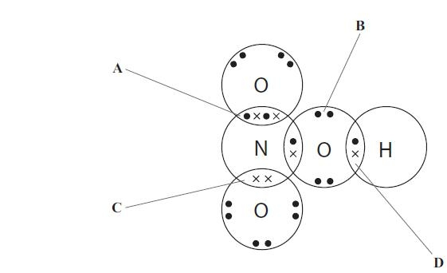
(a) Identify which of the labelled sets of electrons represents a dative covalent bond.
(1)
A
B
C
D
(b) In terms of orbital overlap, the double bond is
(1)
A A π bond.
B two σ bonds.
C two π bonds.
D A σ bond and a π bond.
(Total for question = 2 marks)

Q8.
Buckminsterfullerene has the formula C₆₀. Its structure is shown below.
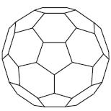
The bonding in buckminsterfullerene is similar to the bonding in graphite.
Which of the following is true?
A All the bond angles in buckminsterfullerene are 120°.
B The melting temperature of buckminsterfullerene is higher than that of graphite.
C There are delocalized electrons in buckminsterfullerene.
D On complete combustion, buckminsterfullerene forms carbon dioxide and water.
(Total for question = 1 mark)

Q9.
What is the total number of electrons in the covalent bonds in a beryllium chloride molecule, BeCl₂?
A 2
B 4
C 6
D 8
(Total for Question = 1 mark)

Q10.
Fullerenes, graphite and diamond are all forms of carbon. Fullerenes dissolve in petrol, but diamond and graphite do not. This is because

A the bonds between the carbon atoms in fullerenes are weaker than in diamond or graphite.
B diamond and graphite are giant structures but fullerenes are molecular.
C there are delocalized electrons in diamond and graphite but not in fullerenes.
D there are covalent bonds in diamond and graphite, but not in fullerenes.
(Total for Question = 1 mark)

Q11.
This question concerns the shapes of the hydrides of Group 5 elements.
(a) What is the approximate H—N—H bond angle in the ammonium ion, NH?
(1)
A 90°
B 104.5°
C 107°
D 109.5°
(b) Suggest the shape of the phosphine molecule, PH₃.
(1)
A Trigonal planar
B Trigonal pyramidal
C Trigonal bipyramidal
D Octahedral

(Total for question = 2 marks)

Q12.
Consider the Maxwell-Boltzmann distribution of energies for a gas shown below. E_{a} represents the activation energy.
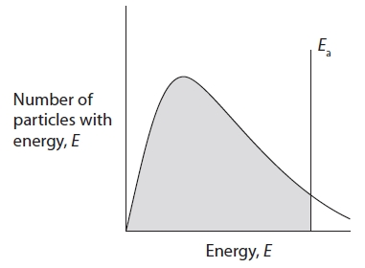
The shaded area of the diagram indicates the total number of particles that
A do have enough energy to react.
B do not have enough energy to react.
C do have enough energy to react in the presence of a catalyst.
D do not have enough energy to react in the presence of a catalyst.

(Total for question = 1 mark)

Q13.
Which of the following molecules has a linear shape and bond angles of 180°?

A CH₄
B H₂O
C CO₂
D SF₆
(Total for Question = 1 mark)

Q14.
Which statement best describes the shape and bond angles in the molecule SF₆?
A Octahedral, 90° and 180°
B Trigonal bipyramidal, 90° and 180°
C Octahedral, 90° and 120°
D Trigonal bipyramidal, 90° and 120°
(Total for question = 1 mark)

Q15.
Which of the following molecules is linear?
A CO₂
B C₂H₄
C H₂O
D NH₃
(Total for Question = 1 mark)

Q16.
The shape of a molecule of boron trifluoride, BF₃, is
A trigonal planar.
B pyramidal.
C tetrahedral.
D T–shaped.
(Total for question = 1 mark)

Q17.
Which of the following molecules has the smallest bond angle?

A H₂O
B NH₃
C CH₄
D SF₆
(Total for Question = 1 mark)

Q18.
Which of the following molecules is linear?
A Carbon dioxide, CO₂
B Sulfur dioxide, SO₂
C Water, H₂O
D Methanal, HCHO
(Total for question = 1 mark)

Q19.
This question concerns the shapes of molecules and ions:
A linear
B trigonal planar
C pyramidal
D tetrahedral
Select from A to D the shape of
(a) boron trichloride, BCl₃
(1)
A
B
C
D
(b) the ammonium ion, NH₄⁺
(1)
A
B
C
D
(c) carbon dioxide, CO₂
(1)
A
B
C
D
(Total for question = 3 marks)

Mark Scheme
Q1.

Q2.

Q3.

Q4.

Q5.

Q6.

Q7.

Q8.

Q9.

Q10.

Q11.

Q12.

Q13.

Q14.

Q15.

Q16.

Q17.

Q18.

Q19.

