Can you sound out the words below?
cat | sat | mat
map | lap | tap
jig | lug | pug
ship | chop | shop
chip | dog | rug
mop | pin | bed
log | lick | flip
flick | chick | fluff
mess | chin | quan
quip | thip | thin
song | think | sink
link | flop | splosh
clash | flash | splash
dress | buzz | bell

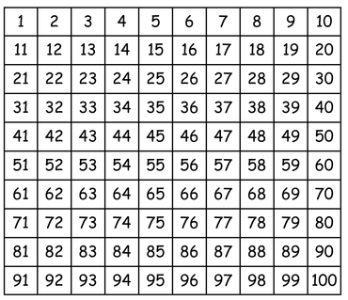

Can you recognise numbers to 20? Try selecting numbers randomly.
Can you order numbers from 1- 20?
Can you count backwards from 20-0?
Can you find one more than a number up to 20? (What is one more than …?)
Can you find one less than a number up to 20? (What is one less than …?)

