Questions
Q1.
Which of the following best defines the meaning of the term anthropogenic change?
It is a change caused by
A nature.
B plants.
C animals.
D humans.
(Total for question = 1 mark)

Q2.
The principal reason why scientists have recommended that chlorofluorocarbons (CFCs) are not used in aerosols is that they cause

A global warming.
B acid rain.
C ozone depletion.
D water pollution.
(Total for Question = 1 mark)

Q3.
One definition of the term 'carbon footprint' is
'the amount of carbon dioxide produced when a fuel is burned.'
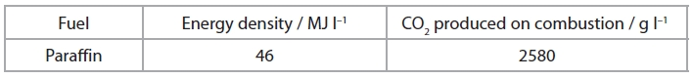
Given the information above, what is the carbon footprint for paraffin in terms of grams of CO₂ produced per MJ of energy?
A 46
B 56.09
C 2580
D 118 680

(Total for question = 1 mark)

Q4.
Which of the following would not be used to assess whether the use of a biofuel produced from a crop of sugar cane is carbon neutral?
The amount of

A fuel used to operate farm machinery.
B pesticides and fertilisers used.
C energy released per tonne of biofuel.
D fuel used to process the crop.
(Total for Question = 1 mark)

Q5.
Which of the following is not true? Chlorofluorocarbons, CFCs,
A are flammable.
B are greenhouse gases.
C damage the ozone layer.
D are excellent refrigerants.
(Total for question = 1 mark)

Q6.
Which of the following statements is true?
A CFCs and nitrogen monoxide, NO, are involved in the depletion of the ozone layer.
B CFCs act as catalysts for the depletion of the ozone layer, while nitrogen monoxide, NO, does not.
C CFCs and ozone are free radicals.
D CFCs and nitrogen monoxide, NO, are decomposed by UV radiation.
(Total for question = 1 mark)

Q7.
It is important to lower the level of carbon dioxide in the atmosphere because of concerns over which environmental problem?

A Acid rain
B Global warming
C Non-biodegradability
D Ozone depletion
(Total for Question = 1 mark)

Q8.
Which of the following is a pure form of carbon that has both hexagonal and pentagonal rings in its structure and can conduct electricity?
A Charcoal
B Buckminsterfullerene
C Diamond
D Graphite

(Total for question = 1 mark)

Q9.
A 'greener' chemical process will be one that

A uses energy less efficiently.
B forms a non-polluting waste product.
C produces significant amounts of waste.
D makes use of non-renewable resources.
(Total for Question = 1 mark)

Q10.
The following reactions have been used in the chemical industry to make liquid and solid products, allowing any gaseous products to escape into the atmosphere:
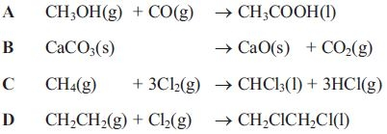
(a) Which reaction has an atom economy by mass of 56%?
(1)
A
B
C
D
(b) Which reaction causes the most immediate damage to the environment?
(1)
A
B
C
D
(c) Which reaction is an electrophilic addition?
(1)
A
B
C
D
(Total for Question = 3 mark)

Q11.
The use of poly(ethene) packaging has been criticised mainly because
A the complete combustion of poly(ethene) produces dangerous fumes.
B large amounts of oil are consumed in producing the monomer, ethene.
C poly(ethene) degrades to form toxic products.
D the catalyst used in the polymerization of ethene is expensive.
(Total for question = 1 mark)

Mark Scheme
Q1.

Q2.

Q3.

Q4.

Q5.

Q6.

Q7.

Q8.

Q9.

Q10.
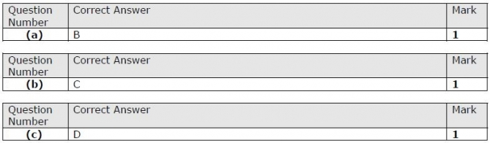

Q11.

