Questions
Q1.
What type of species forms when a bond breaks homolytically?
A Nucleophile
B Electron
C Electrophile
D Free radical
(Total for question = 1 mark)

Q2.
C₂H₅Br + NaOH → C₂H₄ + NaBr + H₂O
This reaction is an example of

A addition.
B elimination.
C hydrolysis.
D oxidation.
(Total for Question = 1 mark)

Q3.
Unsaturated vegetable oils are hardened to make margarine by reaction with hydrogen and a nickel catalyst. Which terms could both be used to describe this type of reaction?
A Substitution and oxidation
B Substitution and reduction
C Addition and oxidation
D Addition and reduction
(Total for Question = 1 mark)

Q4.
Chloroethane reacts with aqueous potassium hydroxide solution, producing ethanol as
the organic product.
(a) The hydroxide ion is acting as
(1)
A an electrophile.
B a nucleophile.
C an oxidizing agent.
D a reducing agent.
(b) Which of the following shows the correct electron-pair movements in this reaction?
(1)
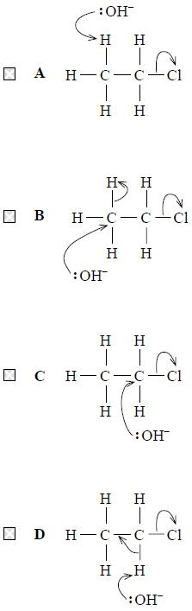
(Total for question = 2 marks)

Q5.
Nucleophiles are
A electron pair donors that attack regions of high electron density.
B electron pair donors that attack regions of low electron density.
C electron pair acceptors that attack regions of high electron density.
D electron pair acceptors that attack regions of low electron density.
(Total for question = 1 mark)

Q6.
Which of the following is essential if a species is to act as a nucleophile?
A A lone pair of electrons.
B A negative charge.
C An unpaired electron.
D A strongly polar bond.
(Total for question = 1 mark)

Q7.
The reaction of 1-chloropropane with water containing dissolved silver nitrate in the presence of ethanol is

A a redox reaction.
B a nucleophilic substitution.
C an electrophilic substitution.
D a free radical substitution.
(Total for Question = 1 mark)

Q8.
The meaning of homolytic fission is

A bond-breaking to form two free radicals.
B bond-making to form two free radicals.
C bond-breaking to form a cation and an anion.
D bond-making to form a cation and an anion.
(Total for Question = 1 mark)

Q9.
A reaction mechanism is shown below.
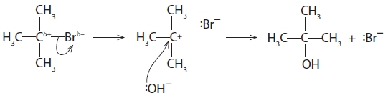
The hydroxide ion is acting as
A an electrophile.
B a catalyst.
C a free radical.
D a nucleophile.

(Total for question = 1 mark)

Q10.
When iodomethane, CH₃I, is heated in a sealed tube with an excess of alcoholic ammonia, which of the following cannot be formed?
A Methylamine, CH₃NH₂
B Ethylamine, CH₃CH₂NH₂
C Dimethylamine, (CH₃)₂NH
D Ammonium iodide, NH₄I
(Total for Question = 1 mark)

Q11.
Four organic reactions are given below:
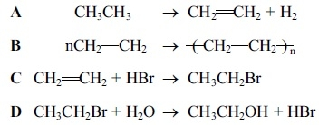
(a) Which reaction is a substitution reaction?
(1)
A
B
C
D
(b) Which reaction is an electrophilic addition reaction?
(1)
A
B
C
D
(c) Which reaction involves initial attack by a nucleophile?
(1)
A
B
C
D
(d) Which reaction requires an initiator?
(1)
A
B
C
D
(Total for question = 4 marks)

Mark Scheme
Q1.

Q2.

Q3.

Q4.

Q5.

Q6.

Q7.

Q8.

Q9.

Q10.

Q11.

