Tuesday 17th January 2023
RE: Author visit and workshop
Dear Parents and Carers,
Gentle reminder about the below information sent out last week. Please note that we will be selling ‘The boy in the Tower’ and ‘The day no one woke up’ this Thursday and Friday after school in the primary pod area. Books are on sale for £8 each and we ask that children bring in cash. Polly will remain after school on Monday 23rd to sign books. Please be aware that we have a limited supply of books on sale.
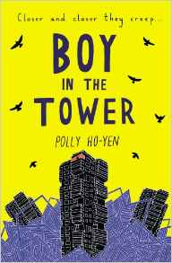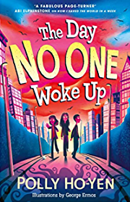

On 23rd January 2023, we are planning an exciting event for the children. Polly Ho-Yen, author of ‘Boy in the Tower’ and ‘Where Monsters Lie’, has agreed to visit the school to do an assembly for pupils in the morning and workshops for year 6 in the afternoon.

Polly is a renowned author and we are delighted to have secured a visit by her. She will be talking to the children to provide inspiration for their own writing and also enthusing them about the joy of reading. This will support the literacy work that we do in school and we hope it will prove a stimulating experience for the students.

Afterwards there will be an opportunity for the children to buy a book and get it dedicated to them and signed by Polly. A signed book can be a permanent reminder of a special experience and can reinforce the message about the importance of reading. The books are approximately £6.50 and we hope to sell them the week before her visit and on the day. If your child would like to purchase a book, please send them in with cash. Of course, if your child already owns any of Polly’s books, they can bring those in and she will be happy to sign them.

We are sure you will agree that this is an opportunity not to be missed and the children can look forward to a very exciting day.

Yours sincerely,
Ms Rafe
Assistant Principal & English Lead

