|  |
| --- |
| Knowledge Organiser |

|  |  |  |  |
| --- | --- | --- | --- |
| **Sport focus:** | **Gymnastics** | **Year 3** | **Spring 1** |

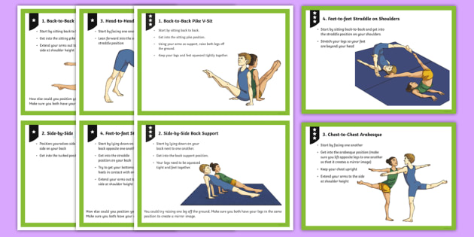

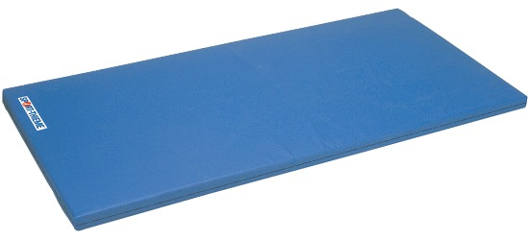

**What? (Key Vocabulary)**

|  |  |
| --- | --- |
| **Spelling** | **Definition/Sentence** |
| **Warm up** | Preparing our bodies for exercise, pumping blood around our bodies faster, to prevent injuries |
| **Cool down** | An easy exercise, done after exercise, to allow the body to transition to a resting |
| **Flexibility** | The range of motion through which a body part can move without feeling pain. |
| **Control** | When performing a sequence, balance or when pupils are stopping, pupils should be taught to hold still |
| **Routine** | A combination of stunts displaying a full range of skills on one apparatus. |
| **Sequence** | Two or more positions or skills which are performed together creating a different skill or activity. |

|  |
| --- |
| **Diagrams and Symbols** |

|  |
| --- |
| **Possible Experiences** |

Space Travel

Rock and Roll

Steady Ready

Feet of the Ground

Sequences

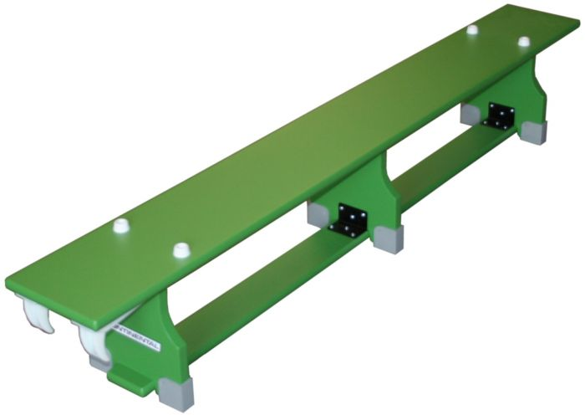



**What? (Key Knowledge)**

|  |  |
| --- | --- |
| Teaching Points | |
| How to link ideas, skills and techniques with control, precision and fluency when performing basic skills (balances and rolls) with a partner. |  |
| Understand composition by performing more complex sequences including rolls and partner balances. |  |
| Describe how to refine, improve and modify performances. |  |
| Perform safely on basic equipment. |  |
| Rules | |
| The lesson should always start with a warm up | |
| The teacher should always be in a position to view all children working | |
| The lesson set out should allow for differentiation | |
| Children should be working in bare feet | |
| The lesson should conclude with a cool down | |
| Questions | |
| Q. How can we link movements, shapes and balances together?  A. Creating a sequence / routine | |
| Q. How can we ensure our performance is of good quality?  A. Good control and fluency | |
| Q. Can you name the different types of rolls?  A. pencil, teddy bear, forward and egg | |
| Q. What can we put in between our legs to make sure we keep them together?  A. A bean bag | |