Y5/6 PE Knowledge Organiser— Athletics

Key Knowledge  Learn these key facts—key points in red | Key Vocabulary  Understand these key words |  | Officiating Focus
Track: Running Events  75m sprint: Running as fast as you can from the start until the finish  600m: Endurance race meaning you can’t sprint the entire race. You need to pace your race so that you don’t get too tired too quick- ly but have still run as fast as you can.  How quickly can you complete the races?  Relay Changeover  Passing the baton to the next runner is a vital  aspect of a relay race. The next runner needs to be moving when the  changeover is made. This allows the runner get to their top speed quicker and will finish the race in a faster time.  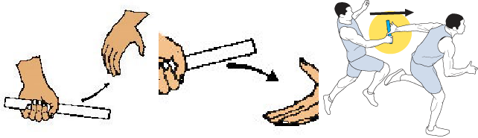 | Word | Definition | Officiating each other is vitally important in  athletics, this shows a good understanding and  demonstration of both rules and technique.  It also applies lots of  mathematical knowledge to  working out distances,  lengths and times—  rounding is also used.
 | Officiate | To assist running events by applying rules
 | Analysis | Be able to look at performance and suggest improvements.
 | Technique | Understand the set of actions required for each activity.
 | Relay Changeover | How the baton is passed from one runner to the next.
 | Momentum | Creating speed that is used to transfer into power for a jump, throw or to gain top speed as quickly as possible | Personal skills such as honesty and fairness are also important when officiating.  Communication—giving  clear instructions or feedback.
 | Finishing line | The point at which the timer stops—You  DO NOT STOP HERE!
 | Hurdles | An obstacle that a runner may have to jump over during a race
Field: Jumping and Throwing
Howler Throw: Overarm throw trying to launch the howler as far as possible. A straight or bent arm technique can be used
Long Jump: Using a run up for momentum, taking off on one foot and landing on two. This is usually done into a sand pit. How far can you jump?
 | Consistency | Being able to perform the same skill accurately repetitively.
 | Endurance | Being able to repeat a specific movement–  running a long distance
 | Explosive Power | Force generated by your body to make your body jump.
 | Relay | Working as a team to complete a race with  a baton.

