Kaizen Primary School - Knowledge Organiser

Sport focus: | Tag Rugby | Year 1 | Cycle 1
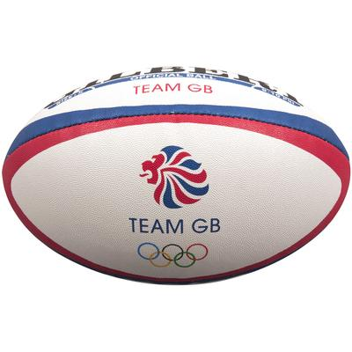
What? (Key Vocabulary)
Spelling | Definition/Sentence
Warm up | Preparing our bodies for exercise, pumping blood around our bodies faster, to prevent injuries
Cool down | An easy exercise, done after exercise, to allow the body to transition to a resting
Rugby ball | An oval shaped ball used in tag rugby
Tagging | Making contact with the ball carrier or attacking player
Dodging | Changing direction quickly, avoiding contact with the opposition.
Throwing | Releasing an object from their hand, over arm/under arm aiming to land at the chosen target
Catching | The ability to track the ball with your eyes all the way into your hands securely

Diagrams and Symbols

Possible Experiences

Tag
Eggs in the nest
Passing in 2s
Tag gate

What? (Key Knowledge)

Teaching Points
Catching a ball with basic control.
Passing a ball in the direction of another person.
Taking part in sending and receiving activities in pairs in any direction.
Take part in basic opposed condition games that involve tagging.
Talk about exercising, safety for tag rugby and short term effects of exercise
Rules
Players can run with the ball until tagged
Players must remain on their feet at all times
The ball must be placed on the floor to score
When tagging, players must shout ‘tag’ and stand still.
Questions
Q. What are the benefits of carrying the ball in two hands?
A. More control, more options to pass
Q. What can we do to avoid being tagged?
A. Be aware of space and gaps in working area.
Q. What do we need to say when tagging someone?
A. Tag
Q. What do we need to do to avoid getting tagged?
A. Dodge the defenders

