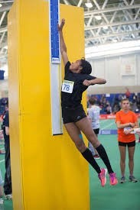
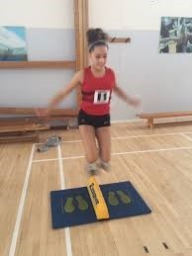
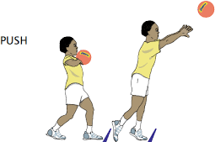
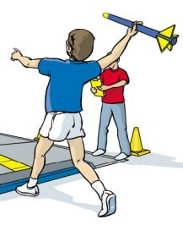
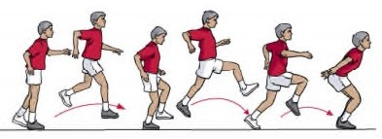
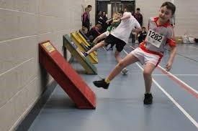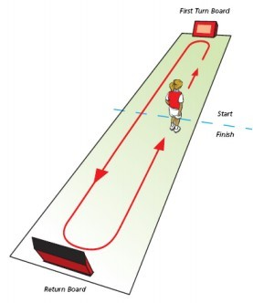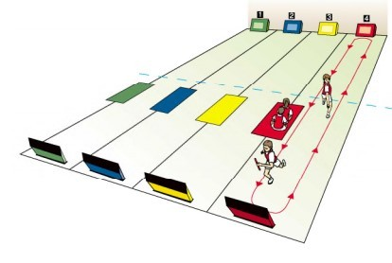
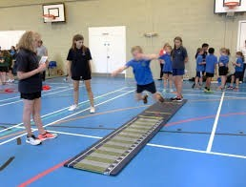
Y5/6 PE Knowledge Organiser— Indoor Athletics

Key Knowledge  Learn these key facts—key points in red |  | Key Vocabulary  Understand these key words |  | Officiating Focus
Jumping |  | Word | Definition | Officiating each other is vitally important in  athletics, this shows a good understanding and  demonstration of both rules and technique.  It also applies lots of  mathematical knowledge to  working out distances,  lengths and times—  rounding is also used.  Personal skills such as honesty and fairness are also important when officiating.  Communication—giving  clear instructions or feedback.  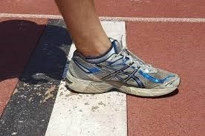
Long jump—two foot-
 |  | Officiate | To assist running events by applying rules
ed single jump for-
ward. |  | Analysis | Be able to look at performance and
Triple Jump—hop, |  |  | suggest improvements.
step and jump (single footed jumps)
 |  | Technique | Understand the set of actions required for
 |  |  | each activity.
Vertical Speed Bounce—  jump— in 20 seconds |  | Relay Changeover | How the baton is passed from one runner  to the next.
how high how many 2
can footed side to |  | Agility | The ability to speed up / slow down and
jump? side jumps can |  |  | change direction.
you do? |  | Finishing line | The point at which the timer stops—You
 |  |  | DO NOT STOP HERE!
Running
Running starts in the middle of the hall goes to one end then
the other and back to the
middle (1 lap) -
sometimes obstacles are on the track too. Individual or as a team
Throwing
 |  | Obstacle | An object such as a hurdle, post, tunnel or
 |  |  | speed bounce.
Chest push—using a
basketball—try to send it as far as pos-
 |  | Consistency | Being able to perform the same skill  accurately repetitively.
sible. |  | Speed Endurance | Keep going at top speed for a prolonged
 |  |  | time.
Overarm Throw—shuttlecock / foam javelin used. |  | Explosive Power | Force generated by your body to make  your body jump.
How far can you throw it? |  | Relay | Working as a team to complete a race with  a baton.
 |  | Momentum | Creating speed that is used to transfer into
 |  |  | power for a jump, throw or to gain top
 |  |  | speed as quickly as possible

