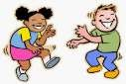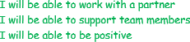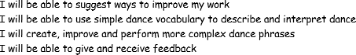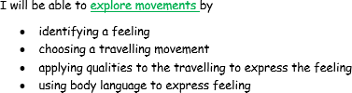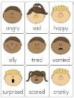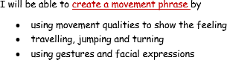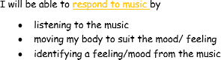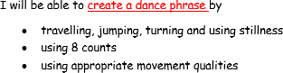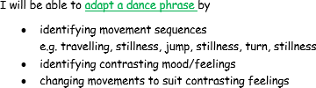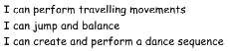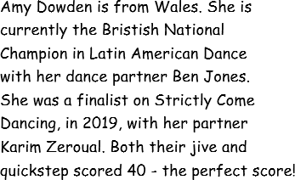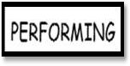
Year 2 Dance Knowledge Organiser

KEY QUESTIONS

How can you change your movements to show a change in feeling?
What movements would suit the music?

How are the moves linked?

How can you travel to convey a feeling?

What gestures
.and or expressions did you choose?
Why?

KEY VOCABULARY
adapt – change and improve sequence

balance –the ability to distribute the weight evenly when stationary or moving around the room without falling over
dance phrase – a sequence of movements or actions

dance sequence – a series of movements longer than a phrase
gesture – a movement of part of the body to show an idea or meaning
jump – leap, spring, bounce, hop, prance, gallop

link – join movements together

travel – skip, gallop, walk , tip toe, crawl, jog, waddle, slide,

