|  |
| --- |
| Knowledge Organiser |

|  |  |  |  |
| --- | --- | --- | --- |
| **Sport focus:** | **Gymnastics** | **Year 2** | **Spring 1** |

|  |
| --- |
| **Possible Experiences** |

Hold and control

Rock and roll

Working with a partner

Traveling (over/on basic apparatus)

Balancing (over/on basic apparatus)

Crabs and scorpions

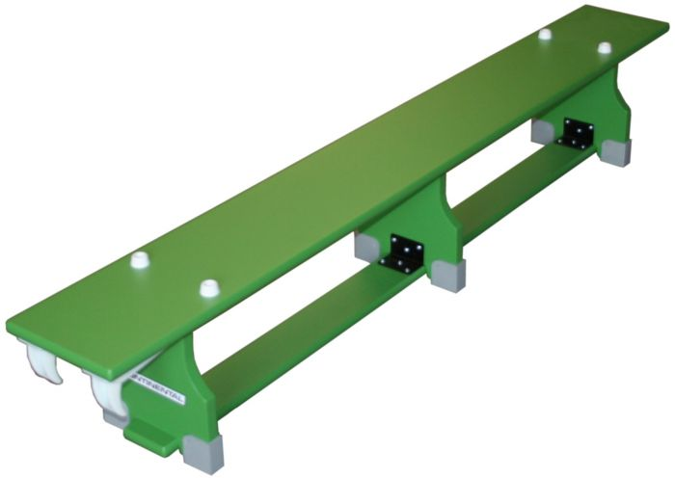

|  |
| --- |
| **Diagrams and Symbols** |



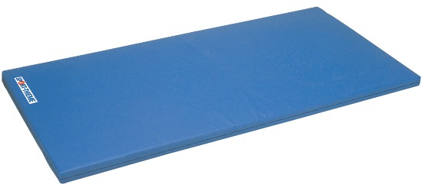

**What? (Key Vocabulary)**

|  |  |
| --- | --- |
| **Spelling** | **Definition/Sentence** |
| **Warm up** | Preparing our bodies for exercise, pumping blood around our bodies faster, to prevent injuries |
| **Cool down** | An easy exercise, done after exercise, to allow the body to transition to a resting |
| **Shapes** | Using your body to create different shapes. The shapes include; straight, start, tuck, pike and straddle |
| **Travelling** | Performing a movement that moves the body, moving in different ways within an area |
| **Sequence** | An order in which related things follow each other. |
| **Apparatus** | The equipment used during gymnastic lessons |

**What? (Key Knowledge)**

|  |  |
| --- | --- |
| Teaching Points | |
| Copy, remember, explore and repeat simple actions such as balances and shapes and link various ideas with control and coordination with a partner. |  |
| Basic rolls such as pencil, log and forward roll. |  |
| How to apply compositional ideas to sequence alone and with a partner. |  |
| How to perform sequences in basic equipment. |  |
| Rules | |
| The lesson should always start with a warm up | |
| The teacher should always be in a position to view all children working | |
| The lesson set out should allow for differentiation | |
| Children should be working in bare feet | |
| The lesson should conclude with a cool down | |
| Questions | |
| Q. Why is it important to communicate when working with a partner?  A. So we understand what we are doing and when we should do it | |
| Q. What can we put in between our legs to make sure we keep them together?  A. A bean bag | |
| Q. Can you name a big body part we can balance on?  A. Back, bottom, all fours, kneels | |
| Q. Why is it important to be able to balance on the floor before balancing on apparatus?  A. To make sure we know what we are doing, to build confidence. | |