|  |
| --- |
| Knowledge Organiser |

|  |  |  |  |
| --- | --- | --- | --- |
| **Sport focus:** | **Gymnastics** | **Year 5** | **Spring 1** |

|  |
| --- |
| **Possible Experiences** |

Rhythmic ropes and ribbons

One to two and two to one

Jump to it

Working with a partner

Mirroring a partner

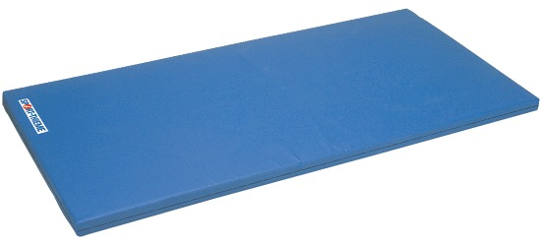







**What? (Key Vocabulary)**

|  |  |
| --- | --- |
| **Spelling** | **Definition/Sentence** |
| **Warm up** | Preparing our bodies for exercise, pumping blood around our bodies faster, to prevent injuries |
| **Accuracy** | The quality or state of being correct or precise |
| **Consistency** | The ability to perform skills / movements correctly over and over again. Impact on Performance. |
| **Composition** | The structure of a routine and how each individual element, movement or skill is arranged into a routine is called the composition of the routine |
| **Routine** | A combination of stunts displaying a full range of skills on one apparatus. |
| **Apparatus** | The equipment used during gymnastic lessons |

|  |
| --- |
| **Diagrams and Symbols** |

**What? (Key Knowledge)**

|  |  |
| --- | --- |
| Teaching Points | |
| How to perform and create movement sequences with some complex skills and display accuracy and consistency. |  |
| Use a wide range of compositional skills in complex sequences alone and in groups. I show an ability to innovate. |  |
| Analyse skills and can suggest ways to improve the quality of performance showing sound knowledge and understanding. |  |
| Lead own warm up and demonstrate all round safe practice. |  |
| Rules | |
| The lesson should always start with a warm up | |
| The teacher should always be in a position to view all children working | |
| The lesson set out should allow for differentiation | |
| Children should be working in bare feet | |
| The lesson should conclude with a cool down | |
| Questions | |
| Q. When giving feedback, why is it important to use positive language?  A. To encourage them to improve, to show what they have achieved is good, to boost confidence, etc | |
| Q. What is purpose of warming up before exercise/ performing?  A. To prepare our bodies for exercise/to prevent injuries | |
| Q. How are we able to improve our performance?  A. Record each performance, ask another group to watch, if working in a group, half of the group perform | |
| Q. What elements are required to perform a sequence?  A. Travel, jump, turn, balance and roll | |