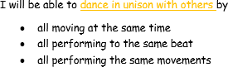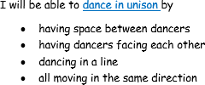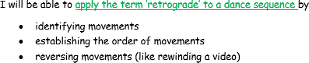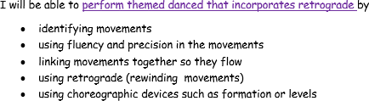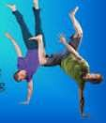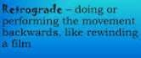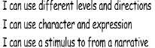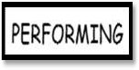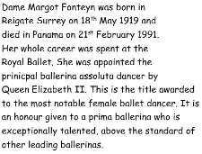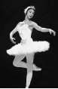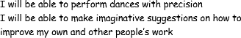
YEAR 5 PE Knowledge Organiser: DANCE

KEY QUESTIONS

What choreographic devices can you use?
What does dancing in unison mean?

How do the dynamics reflect the beat?

What does the term retrograde mean?

How can you adapt your phrase to incorporate another phrase?

KEY VOCABULARY
choreographic devices- a method to manipulate, change or repeat movements to develop a dance

evaluate - discuss the strengths and areas for improvements
mirroring– reflecting movements
retrograde -performing movements backwards sequence– movements performed in a pattern stimuli– inspiration for the movement or dance

unison– performing identical movements at the same time

