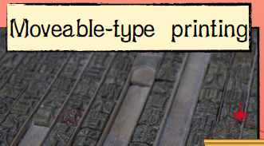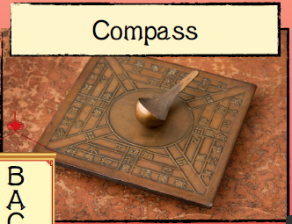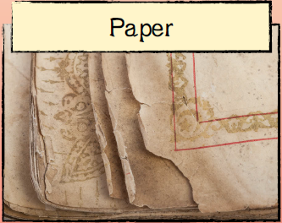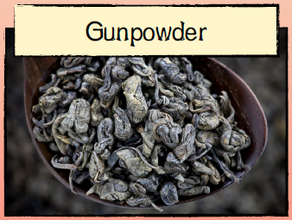

Can I research different Chinese inventions and how they shaped the world?

Can I test my protype and identify any changes?

**Timeline**

Can I reflect and evaluate my kite?

Can I create a kite using a design criterion?

Can I build a prototype kite?

The four great inventions of China.

**Mechanical Systems -** **Chinese Inventions**

**(Inventions and Achievements)**

**Big Question: How did the invention of paper change the world?**

**Key points**

Collect research, explore materials and select appropriate tools and resources to use. Consider appropriate features of kites and select materials fit for purpose.

**Evaluating**

Explore and consider the texture and properties of materials to ensure they are suitable for purpose.

Reflect and evaluate your end product against your design criteria. Consider the views of others to improve your work.

**Mechanical Systems – Storybooks**

**Programming Pioneers:** develop and build a prototype pedestrian crossing using computer programming.

**Moveable-type printing** was invented around 1040 AD in China. Rather than carving a whole woodblock to print, Chinese characters were made from porcelain and placed within a frame, printed and then moved to create the next page of print.

**Gunpowder** - When it was first discovered, alchemists were trying to make a potion to gain human immortality. They mixed sulphur, charcoal and saltpetre together and originally called it ‘fire medicine’. They then realised that when it was packed into a confined space and set alight, it would explode.

**Compass -** Around 206 BC the first round compass was made using lodestone (a naturally magnetic mineral) as the ‘needle’. It was shaped into a spoon or ladle shape and balanced in the centre of a square which marked the eight compass directions. The handle of the spoon would point south.

Design a bridge, and the Build

**Key Skills – How can I re-create a Chinese invention?**

**Star Vocabulary**

Inventions

Material

Lever

Pulley

Architect

Prototype

Paper

Compass

Gunpowder

Movable-type printing

Carved

**Year 5 DT Mechanical systems, Chinese inventions - Knowledge Organiser**

**Chinese inventions**