**What happens in a Mosque?**



**Year 6 Summer 1 Knowledge Organiser**

**What I should know already...**

**What I will learn in the future…**

Facts you should know:

* Islam is a religion followed by Muslims.
* Qur’an is the holy book read by Muslims.
* Muslims believe Muhammad is the founder of Islam.
* Muhammad is known as Prophet Muhammad.
* The Islamic New Year beings on the day Muhammad left.
* It is considered disrespectful to make pictures of God or the prophets in Islam, so mosques are decorated with patterns, calligraphy, and stained glass.

Star Vocabulary

The Qur’an and other sources of authority in Islam.

What is Islam?

What do Muslims believe?

What does it mean to be a Muslim?

**Mosque –** the Muslim place of worship

**Prayer Mat** – a small carpet used by Muslims for kneeling on when praying.

**Qur’an –** is the sacred text of Islam, considered by Muslims to contain the revelations of God to Muhammad.

**Five pillars** – the core beliefs and practices of Islam (Shahada, Salat, Zakat, Sawm and Hajj).

**Niyyah** – entering a state of right intention for prayer

**Wudu –** ritual washing to be performed in preparation for prayer and worship.

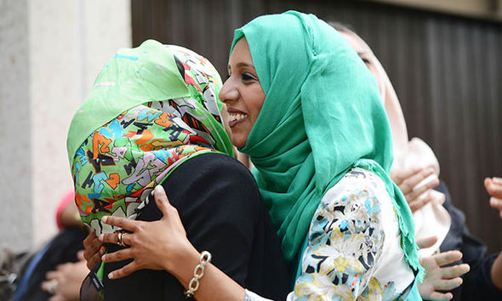

**Attainment skills**

Discuss the connections between beliefs, teachings and the issues that face human societies in the world today by drawing on the perspectives of different faiths and beliefs.



Speak about the variety of religious practices that people of faith follow, explaining how these shape individuals, groups and societies.

Speak sensitively and in a reasoned way about both the benefits and challenges of belonging to a religious community in contemporary society.

Identity some of the most important issues about meaning, purpose and truth and speak about both their own and others’ views on these issues.

Speak about how religions address some of the major questions in human life, identifying how sources of authority underpin these perspectives.

Use appropriate religious vocabulary to explain why different forms of religious and moral expression are important to members of faith and belief communities