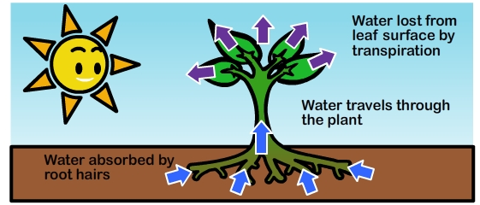

Year 5-Changes and Reproduction-Knowledge Organiser

Year 3 Plants Knowledge Organiser

**Star Vocabulary**

|  |  |
| --- | --- |
|  |  |
|  |  |
|  |  |
|  |  |
|  |  |
|  |  |



Do I understand how the body changes during adulthood and old age?

What are the stages of development during childhood and what are the needs of children at those stages?

Do I know the stages in the gestation period of humans and can I compare them to other animals?

Can I understand the initial changes inside and outside of the body during puberty?

How do the changes that occur during puberty and how they differ for boys and girls?

**Progression**

Can I recognise the stages of growth and development in humans?