Key and Scale – C major, steady beat, meter 2/4, recognise simple notation – minim, crochet, quaver, rest.

Key and Scale – F major, meter 2/4, create melodic patterns using minims, dotted crochets, crochets and quavers.

Year 4 How Does Music Connect Us with our Past?

Joanna Mangona and Chris Taylor

Juan Tizol

Key Resources

* Glockenspiels
* Recorders
* Sheet Music
* Music:
  + Looking in the Mirror
  + Take Time in Life
  + Scarborough Fair

Notation

F Major scale

Key Learning

* To understand the key and scale of F Major – F, G, A, Bb, C, D, E, F
* Find the beat – recognise and move to a steady beat in a 2/4 meter.
* Copy Back Clapping – Listen and copy rhythmic patterns made of minims, dotted crochets, crochets, quavers and rests, by ear or by notation.

Pop, 2020

Folk, unknown

Unknown Artist

Star Vocabulary

**Key signature:** A set of sharp or flat symbols placed on the stave at the beginning of a piece of music.

**Time Signature:**  this tells you how many beats there are in a bar.

**Duration:** the duration is the length of time each note is played for.

**Pulse:** the steady beat like a ticking clock or your heartbeat. It can be measured in beats per minute (bpm)

**Rhythm:** the patter of long and short notes through a song.

**Pitch:** the high or low frequency of a sound.

Folk, unknown

Jazz, 1941

* Music timeline -

Unknown Artist

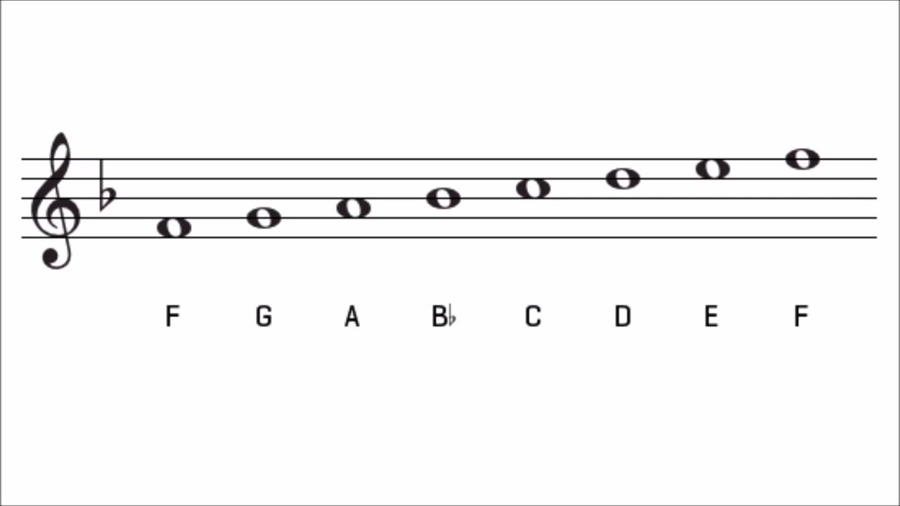

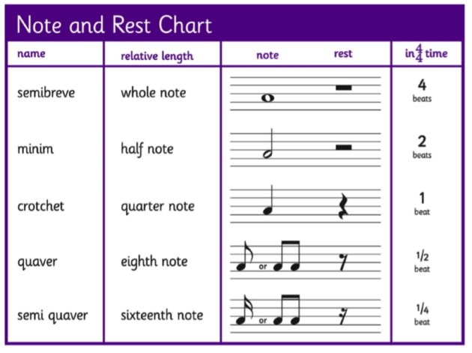

A dot after a note adds a half beat.